A HISTORY OF THE TORPEDO

Geoff Kirby

(Originally published 1972)

In 1972 I published a ‘History of the Torpedo’ as a series of articles in an in-house journal of what was then the Royal Naval Scientific Service. Despite the limited availability of this journal, photocopies of this history were widely circulated in the 1970s.

Part 1 of the series has appeared online and a Google search produces over four thousand citations to it. Part 1 covered torpedo developments up to the end of the nineteenth century. The full set of my articles reproduced below take the history of torpedo development through the first half of the 20th century.

Since 1972 a great deal has been written about the Victorian era and two excellent books by Edwyn Gray comprehensively cover this era , and little further is ever likely to be published that add to these two books.

In the 1950s fantastic schemes were proposed by UK weapon designers for flying torpedoes, flying submarines and submersible aircraft carriers. Detailed information on these imaginative devices was not available in 1972 but subsequently drawings have become available as shown below.

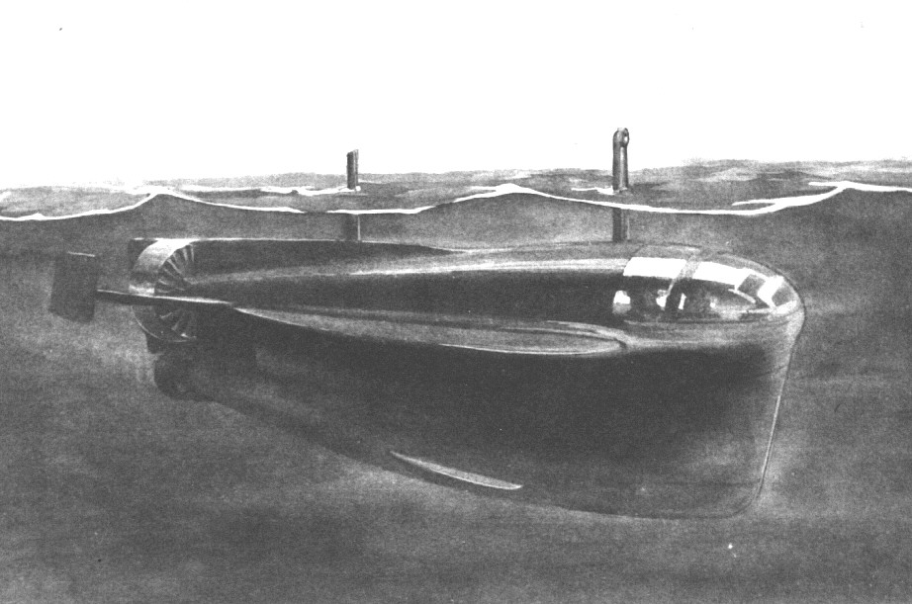

Proposal for a Flying Submarine

Keywords - torpedo history geoff kirby zannet zombi zoster zeta pentane robert whitehead fiume bushnell giovanni luppis silurifico brennan howell brotherhood engine bliss-leavitt sopwith sound of music von trapp japanese long lance torpedo GJK01305 zaunkonig camrose heyday torpedo pfau torpedo falke torpedo lerche torpedo g7a g7e trumper bowler dealer torpedo ingolin steinwal torpedo decalin kaiten marder
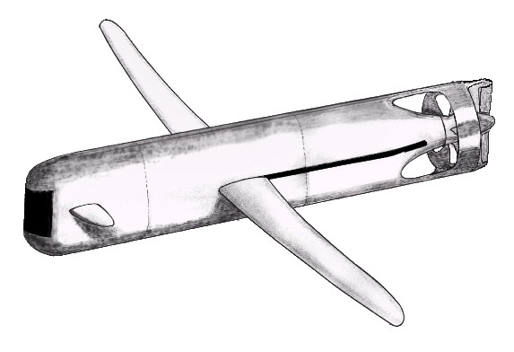

Proposal for a Flying Torpedo

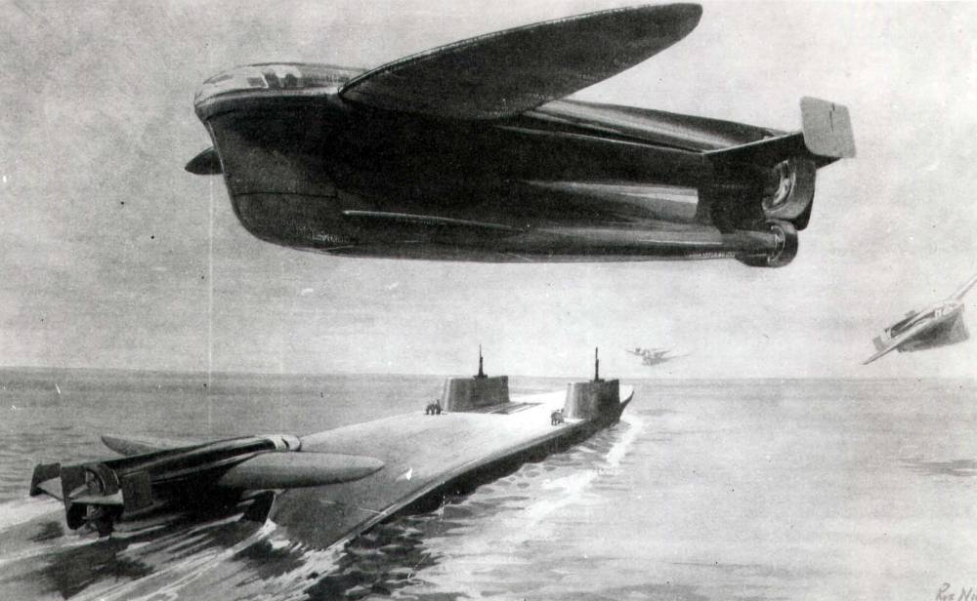

Proposal for a Submersible Aircraft Carrier

Perhaps I will get around to writing up the history of the torpedo for the second half of the 20th century one day?

In 2000 I published an article “The Development Of Rocket-Propelled Torpedoes” in an in-house journal. This covers the history of underwater rocket-propelled torpedoes from the mid-19th century until the end of the 20th century.

As for my articles published in 1972, this much more recent article has been extensively copied and distributed around the world. This was posted online in August 2010 .

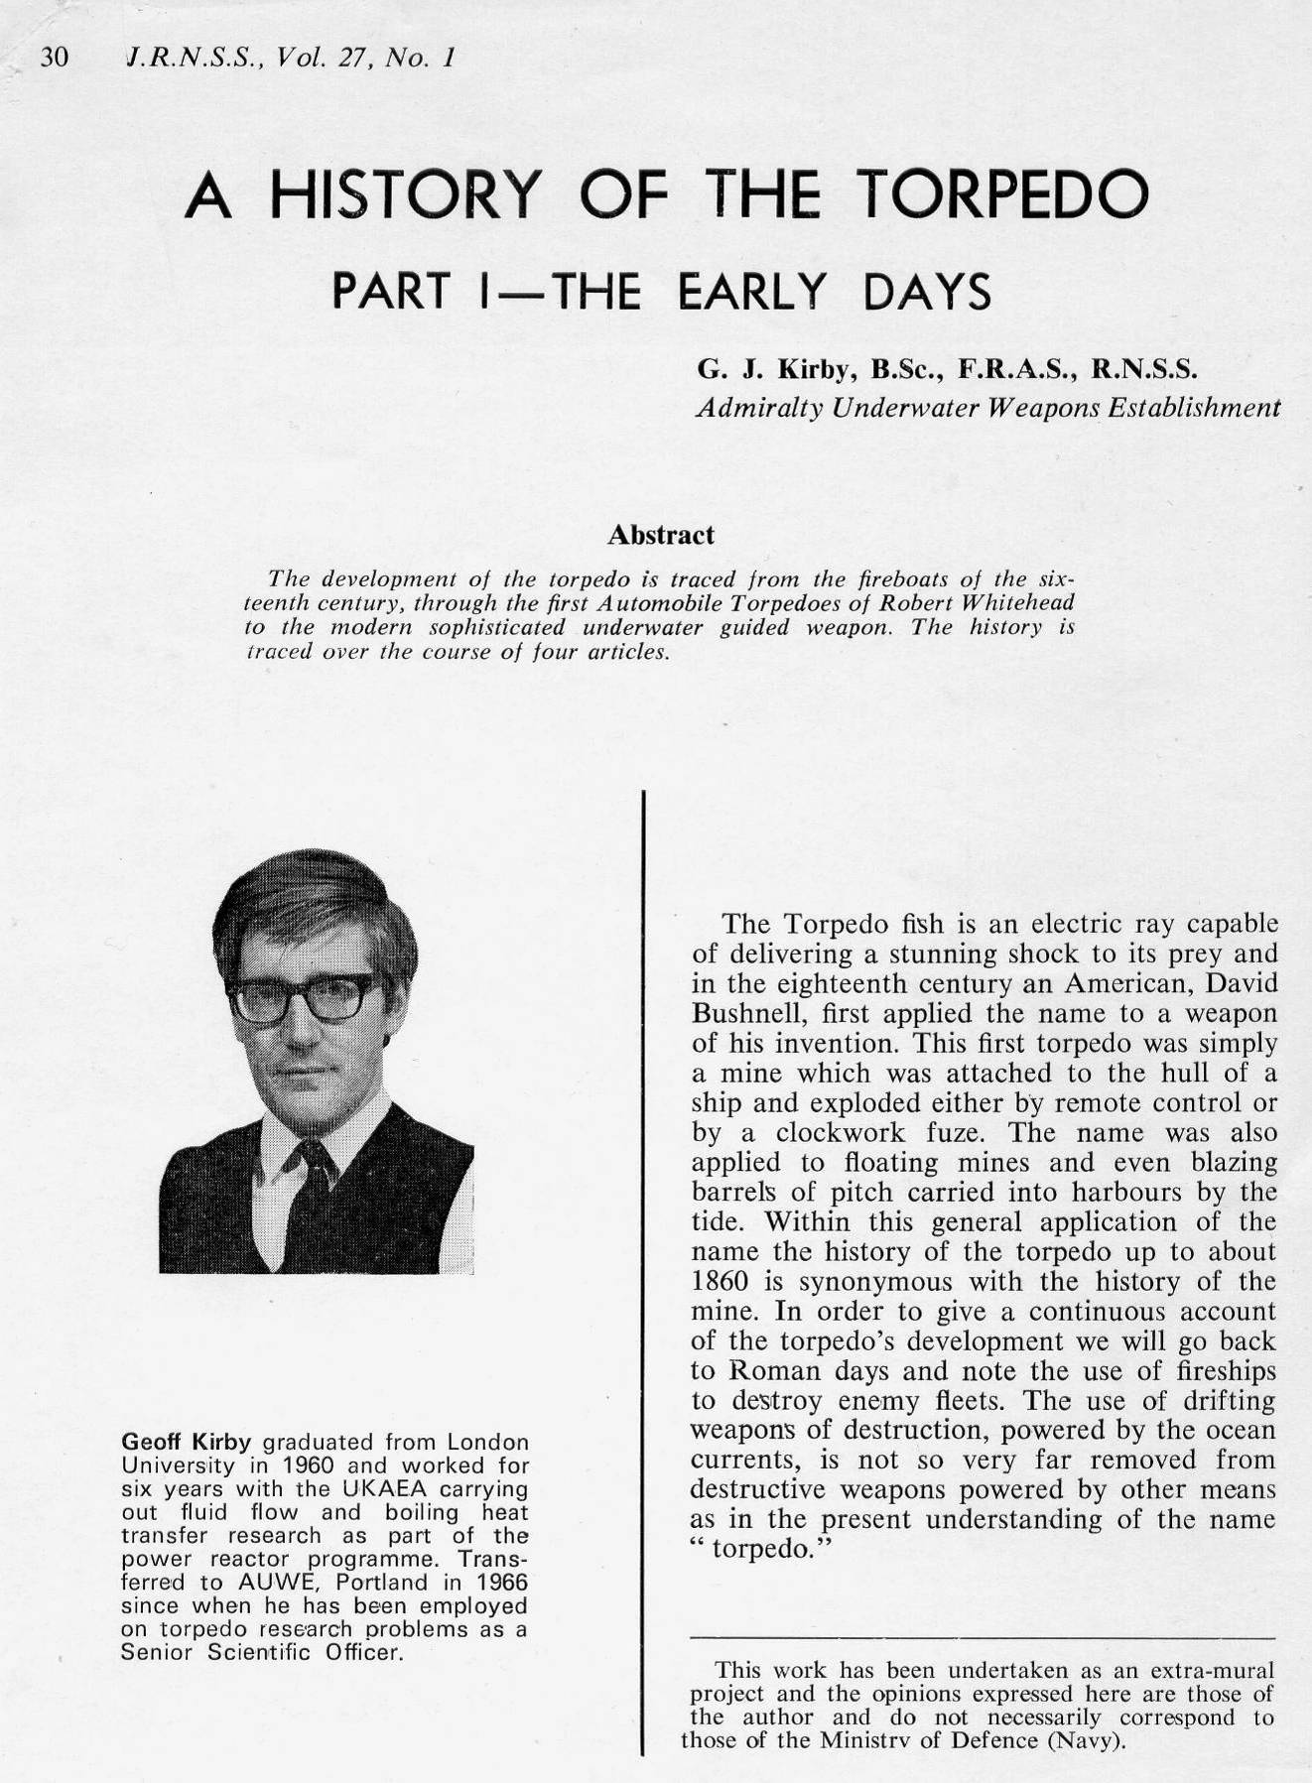
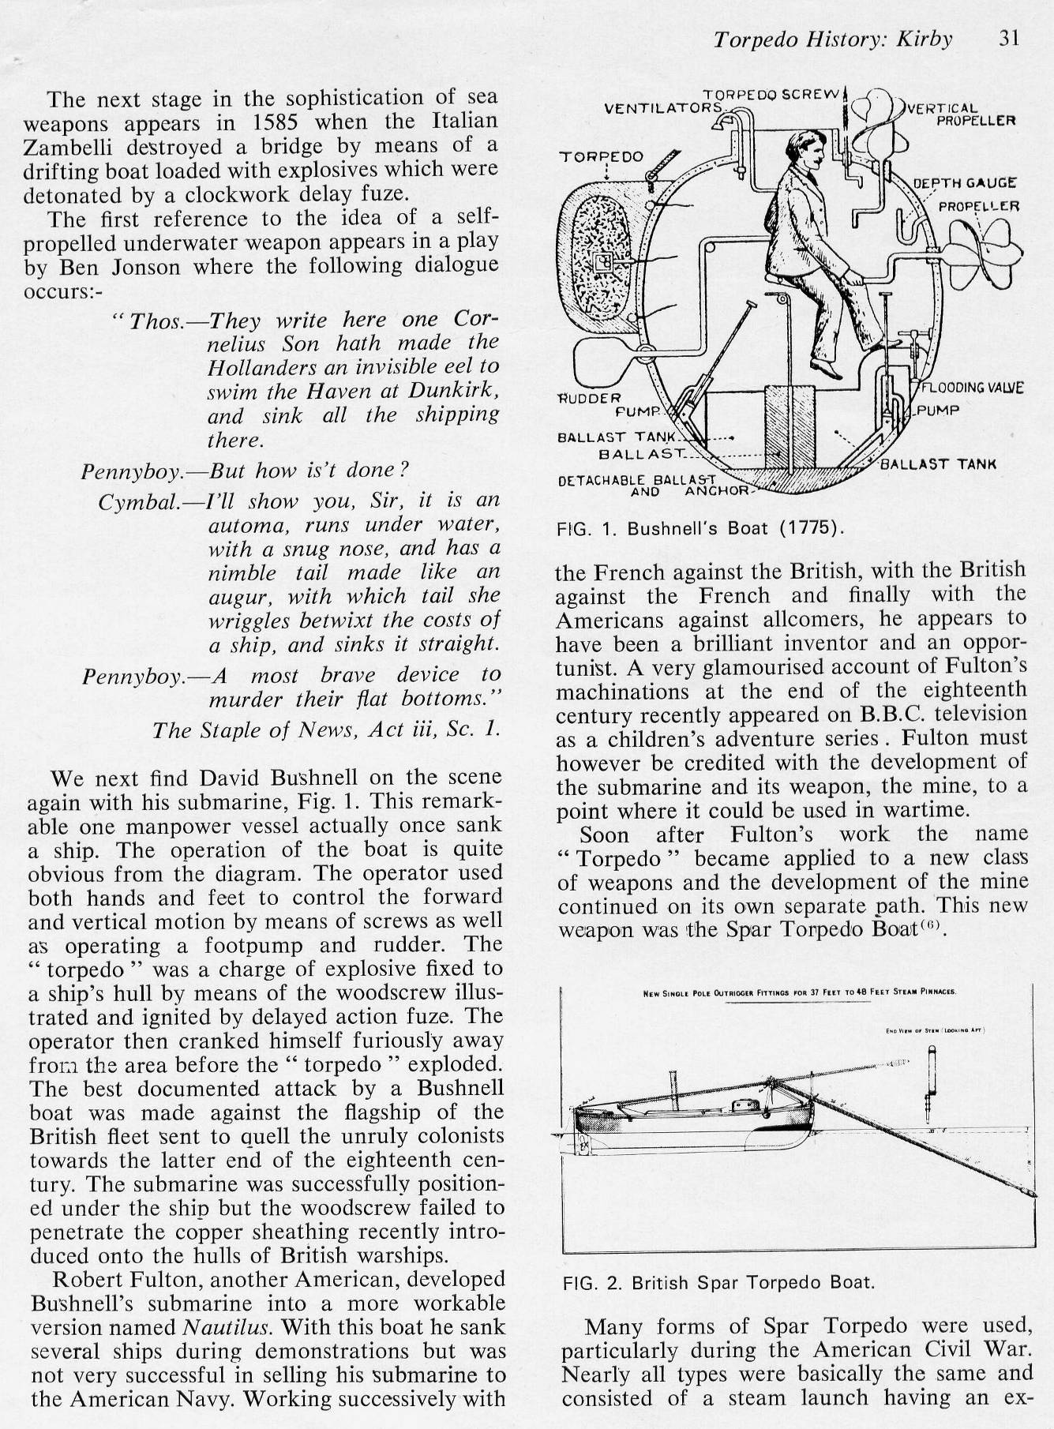
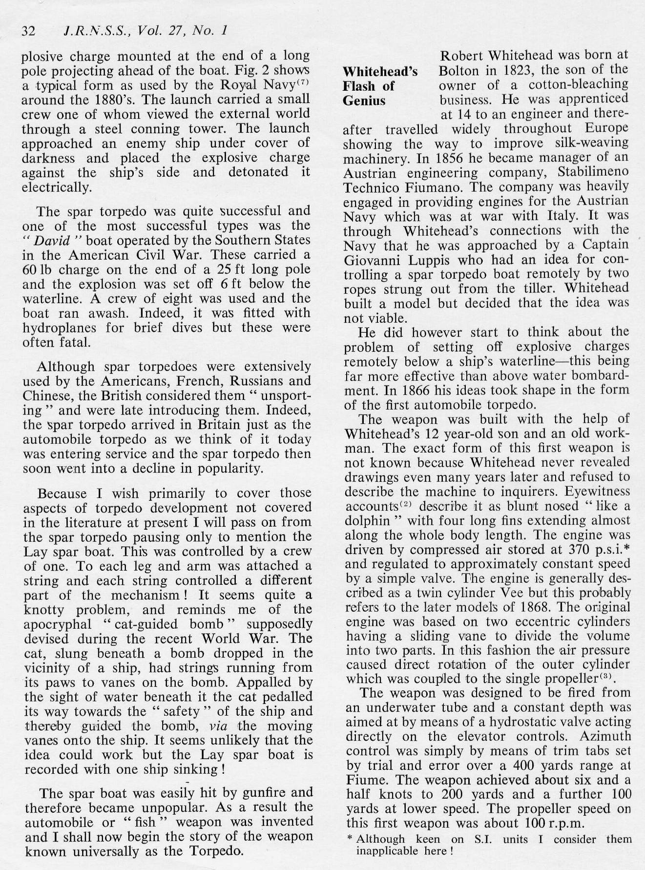

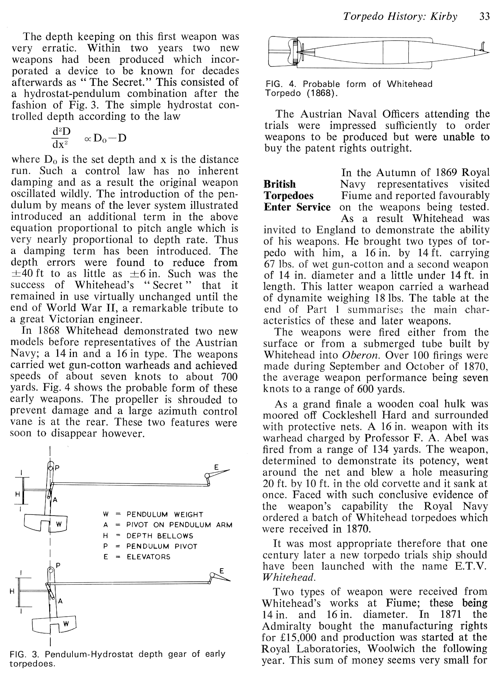

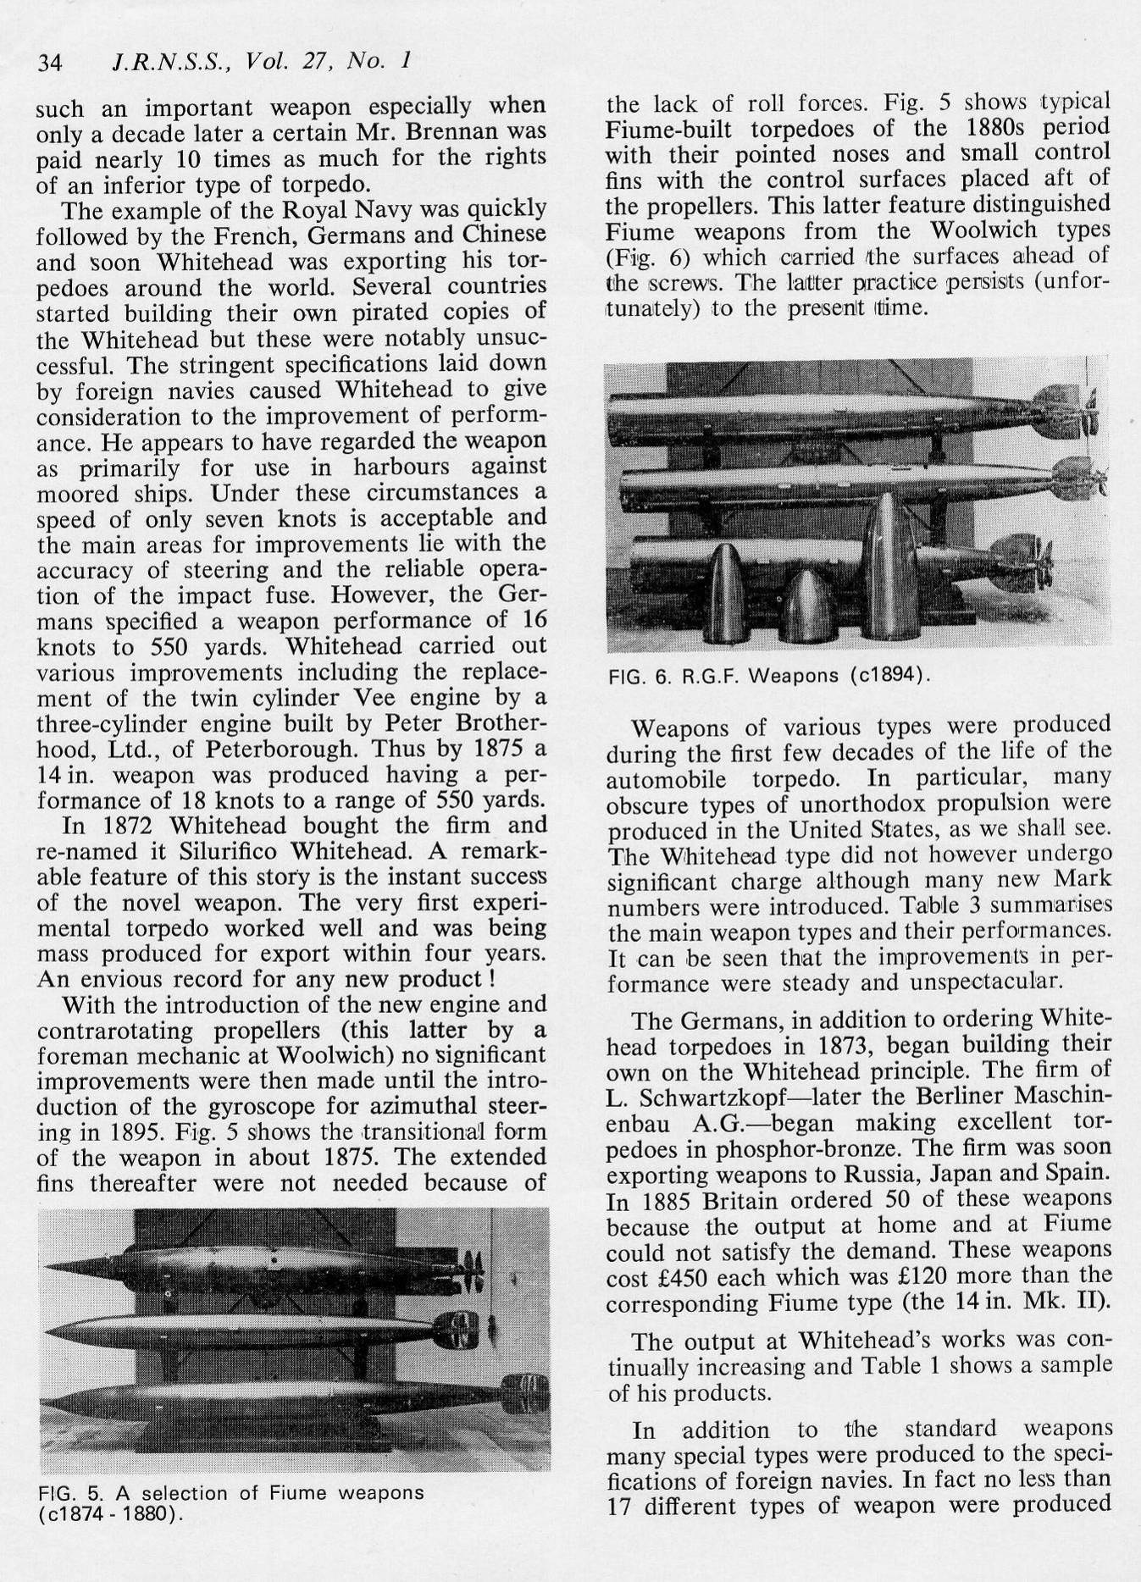

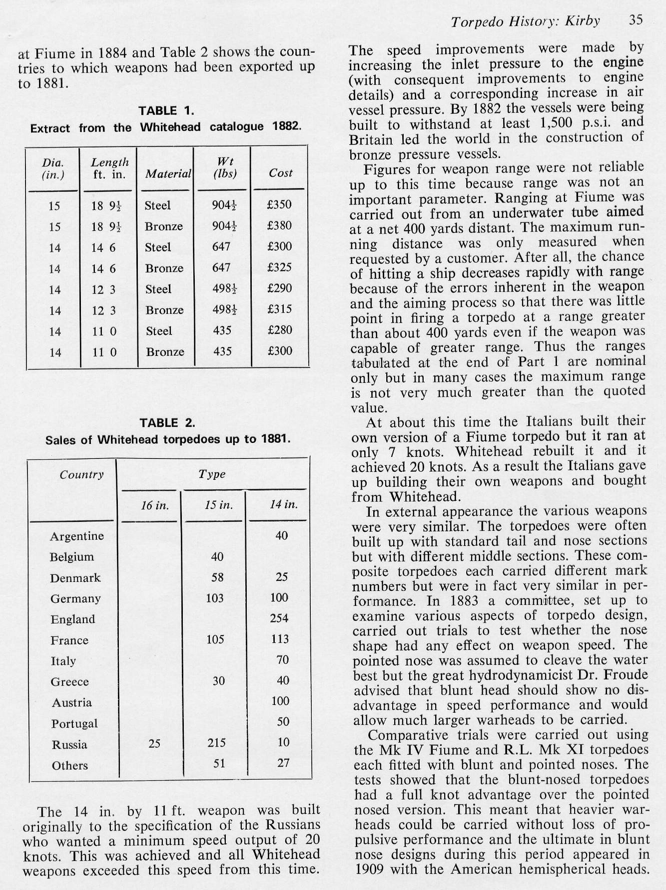

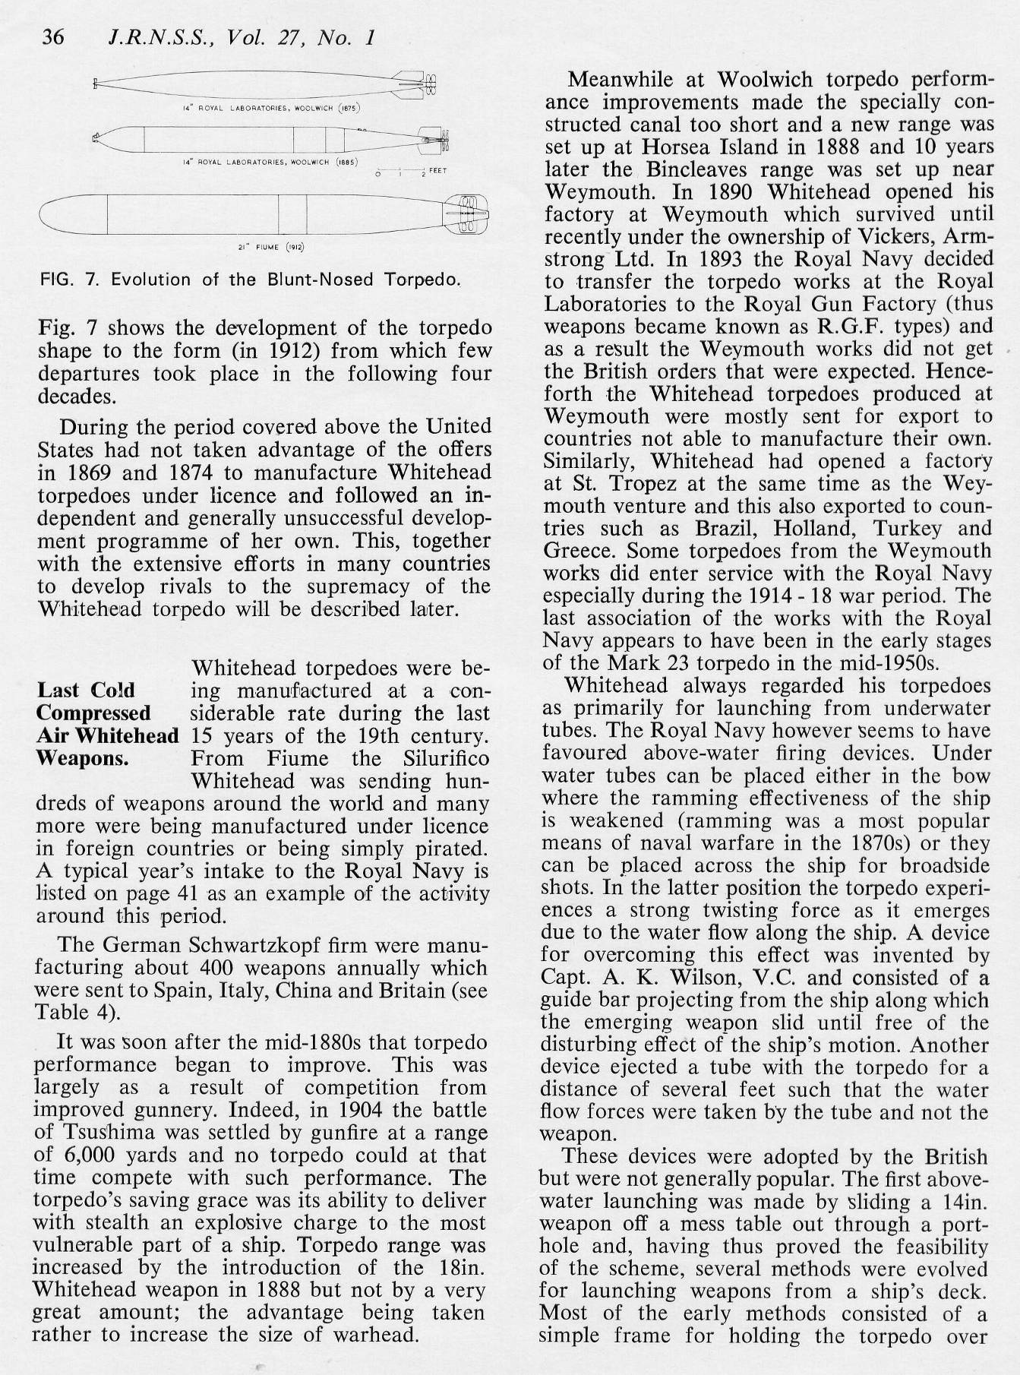
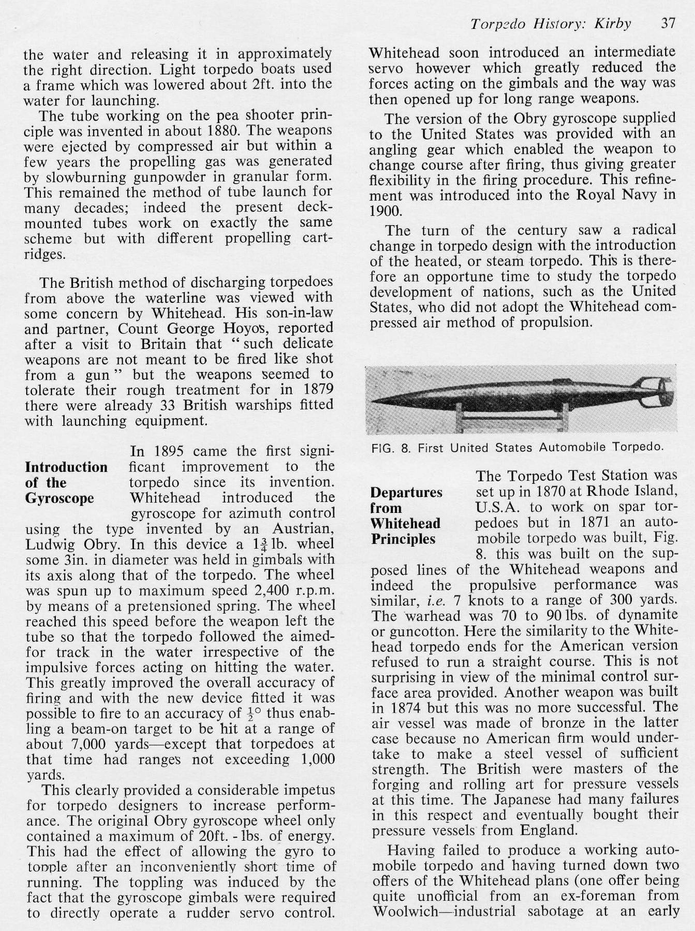
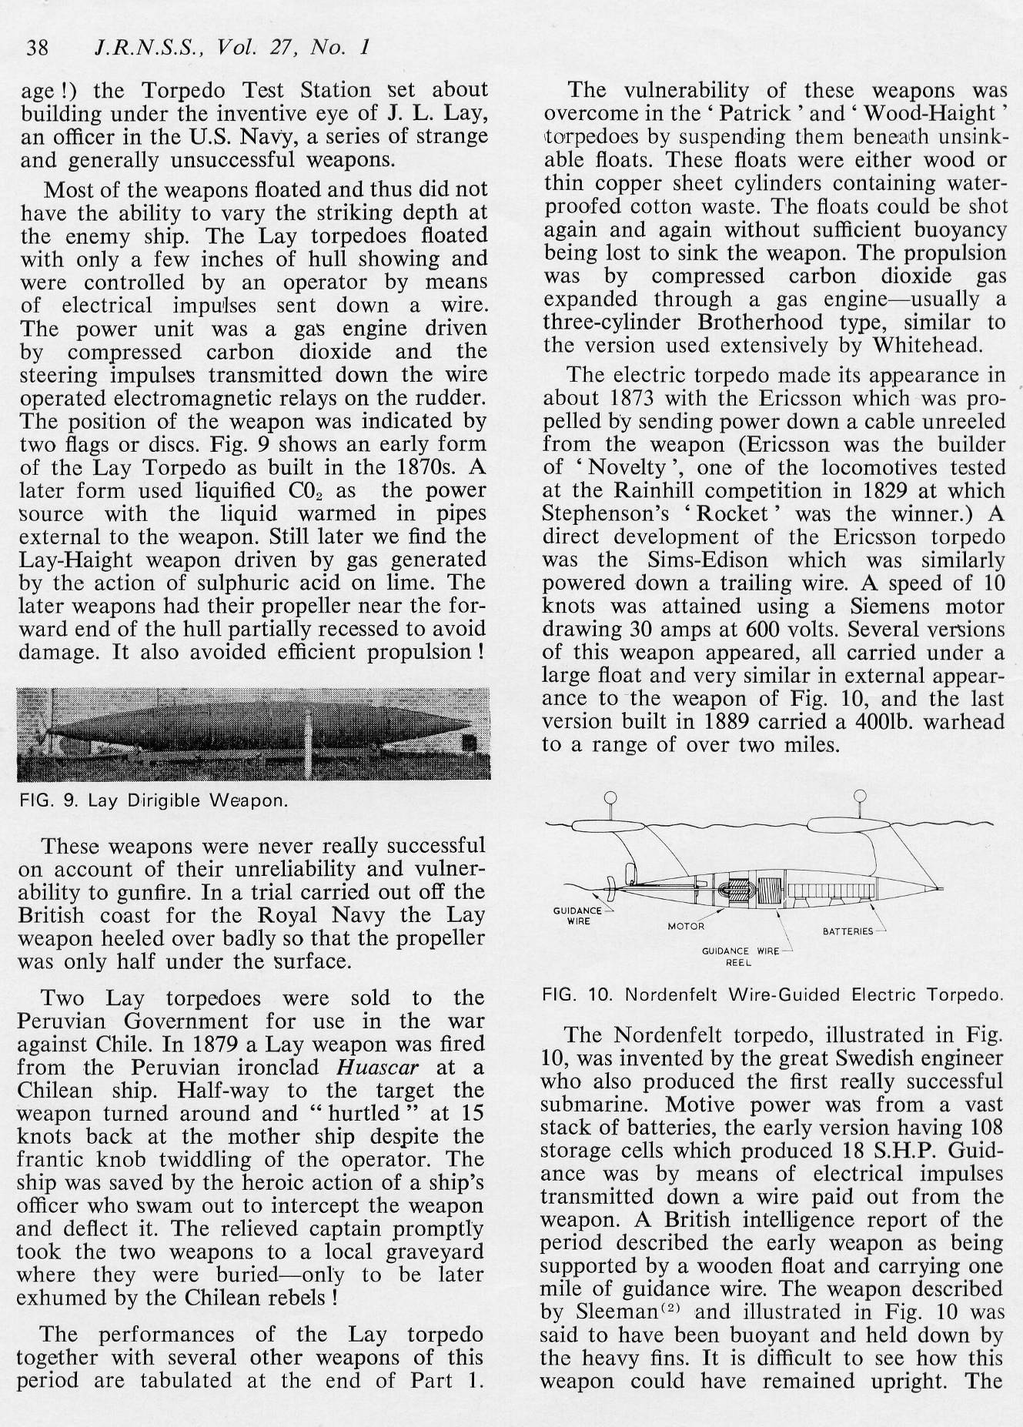
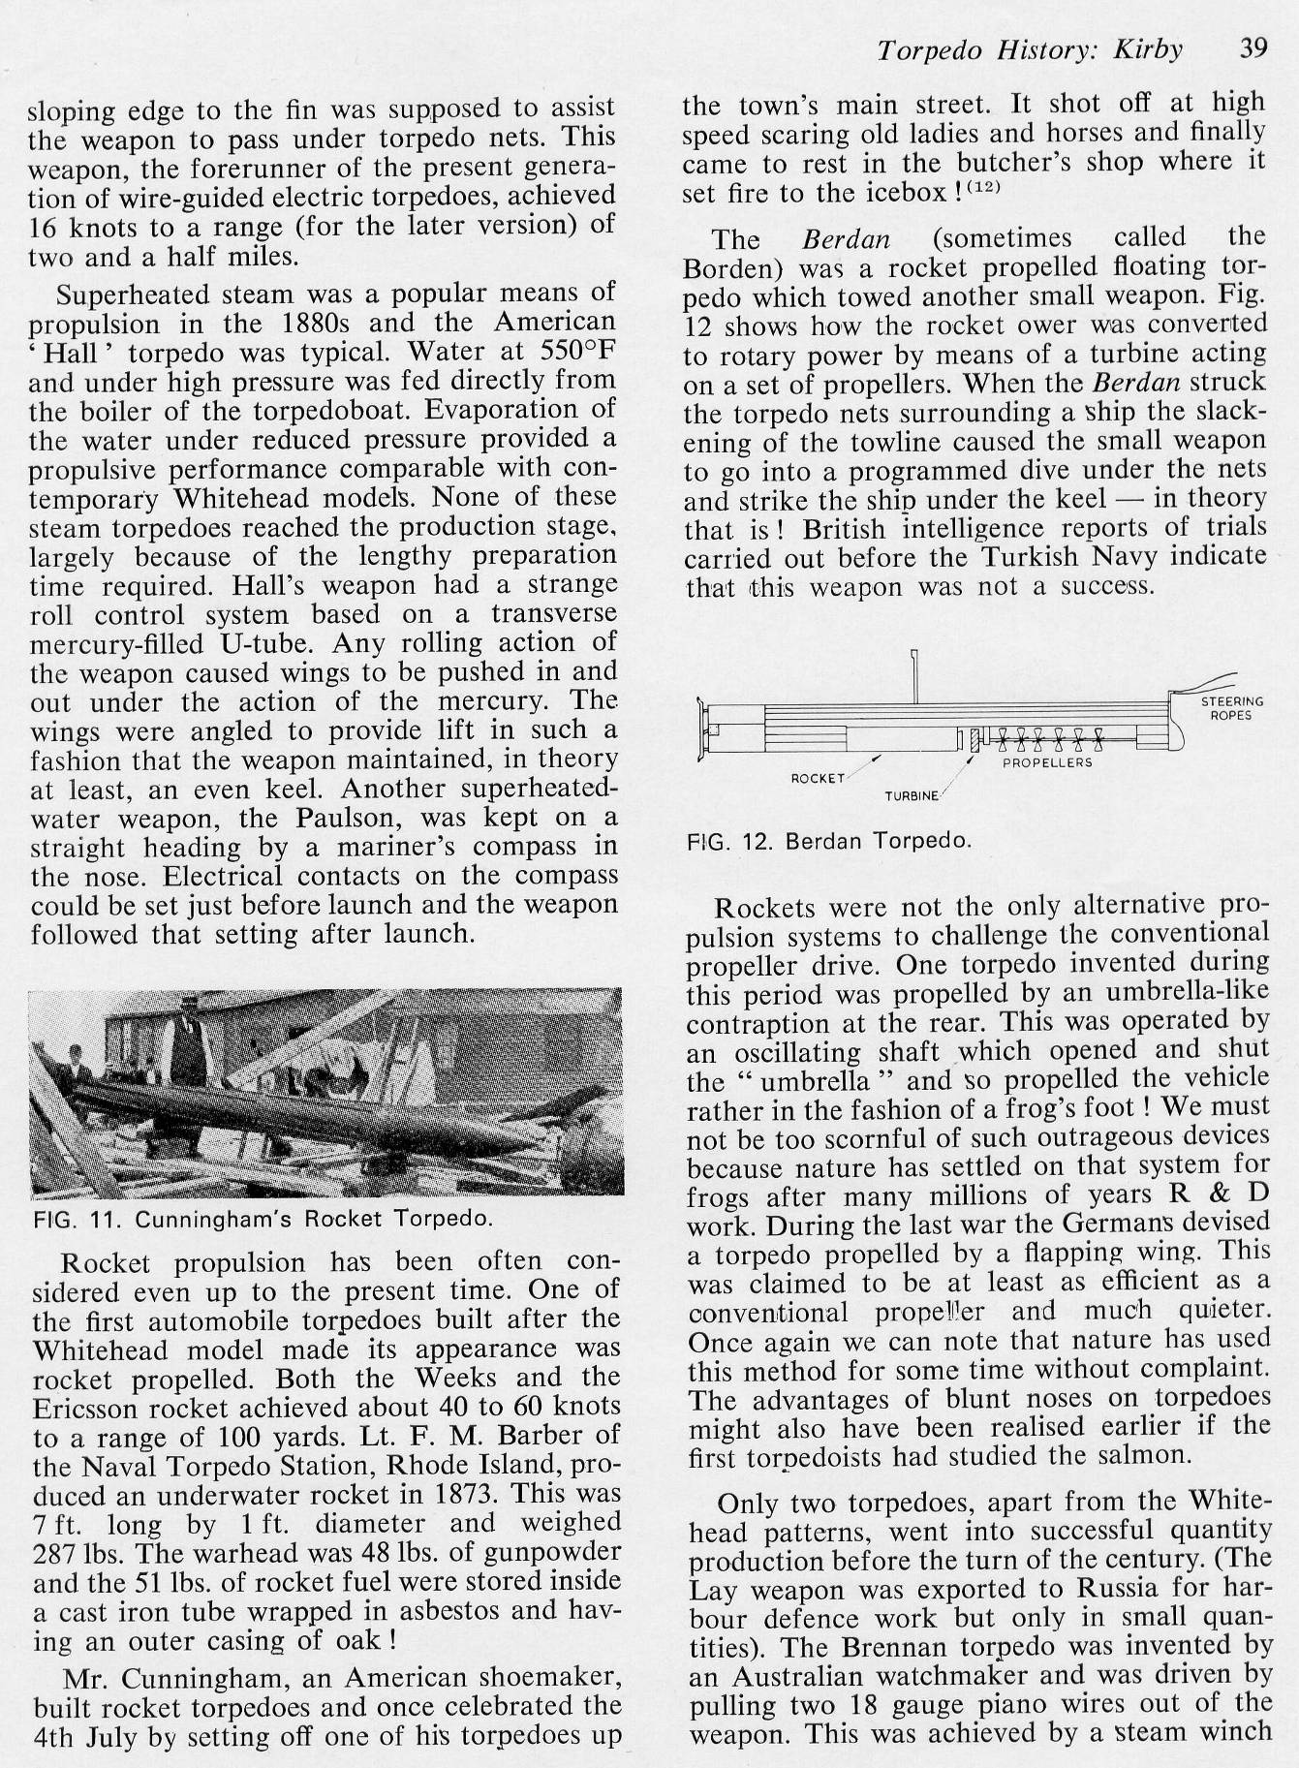

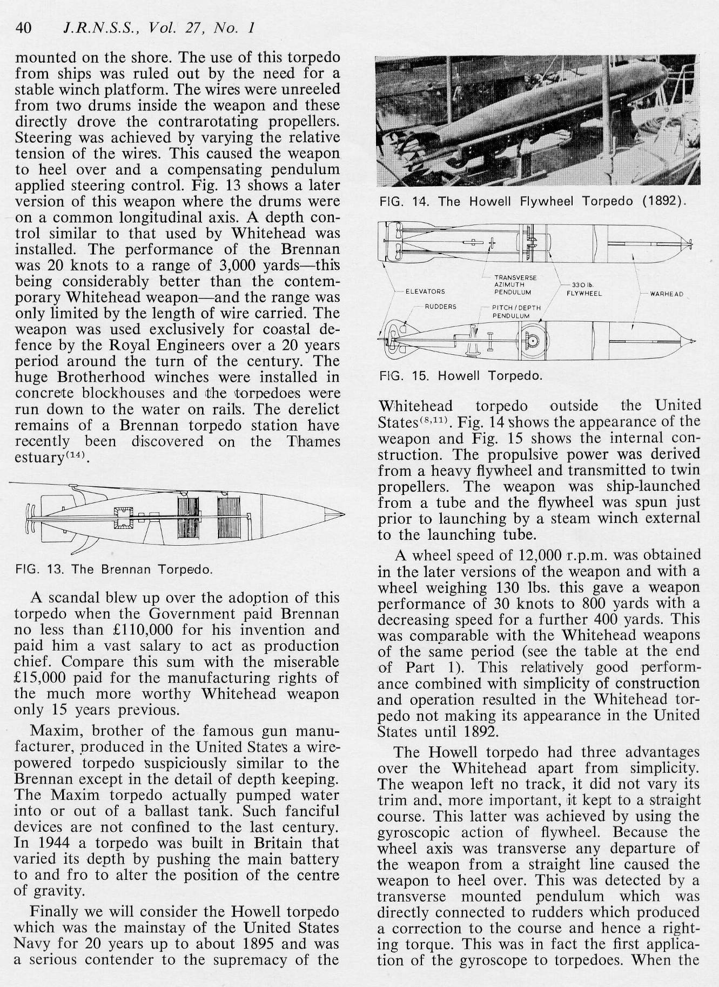

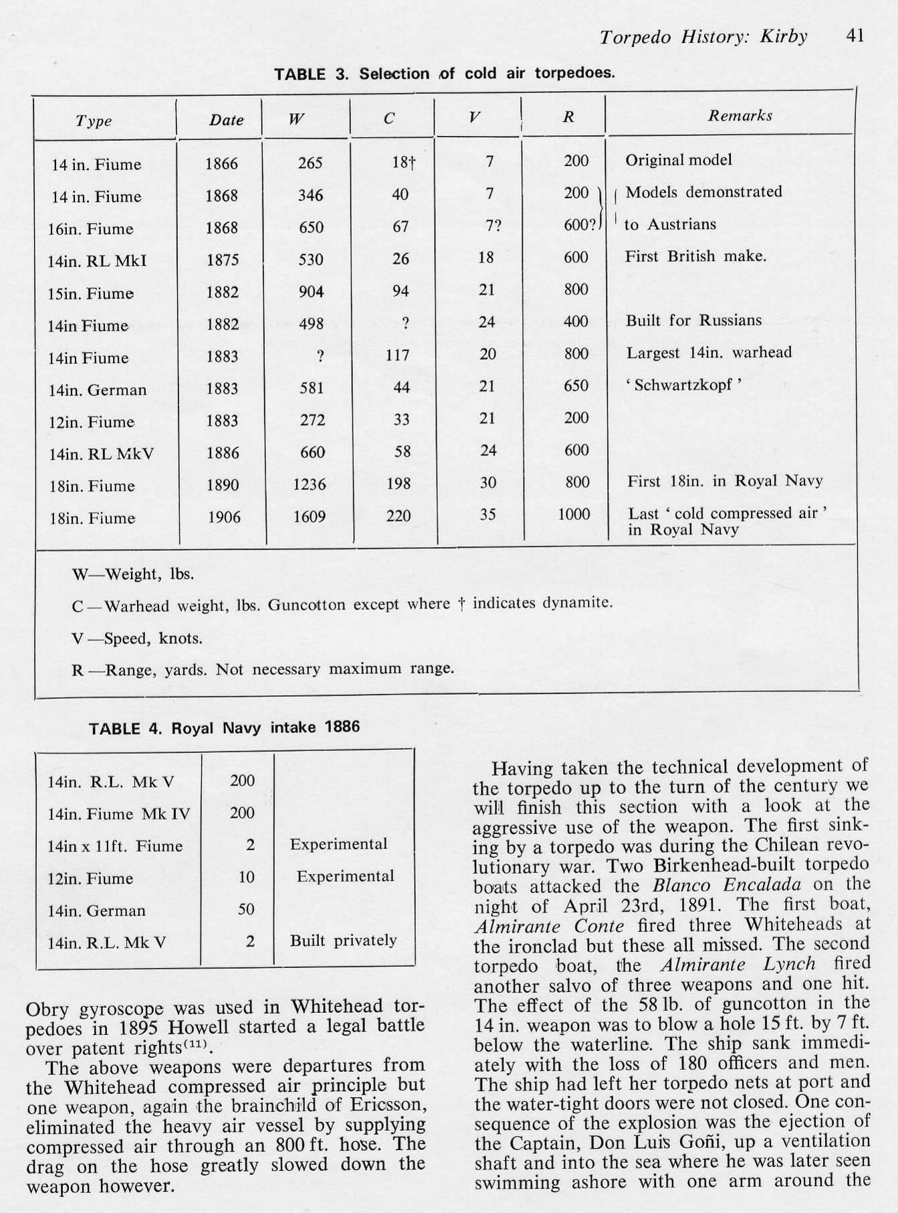

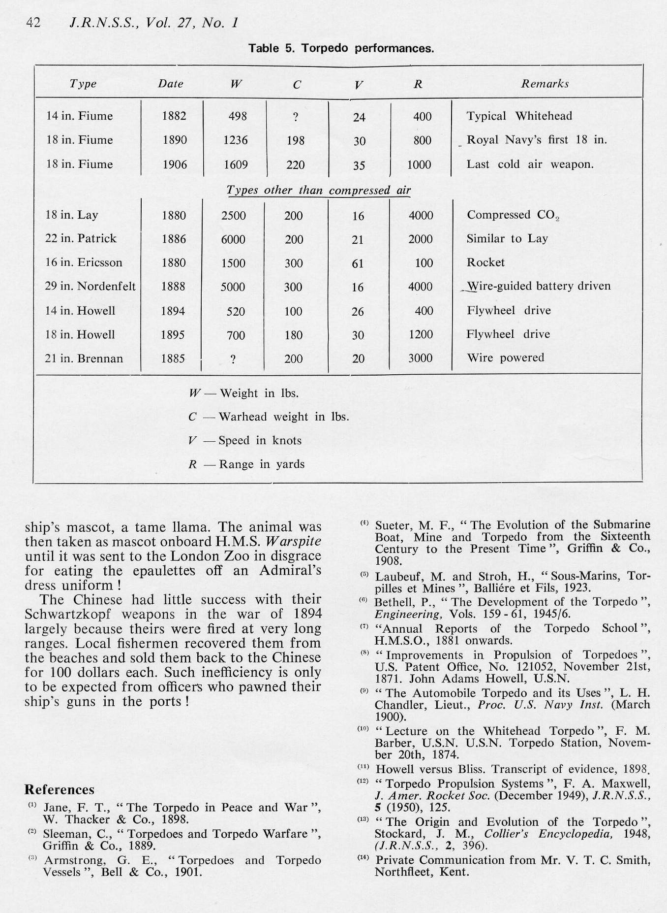

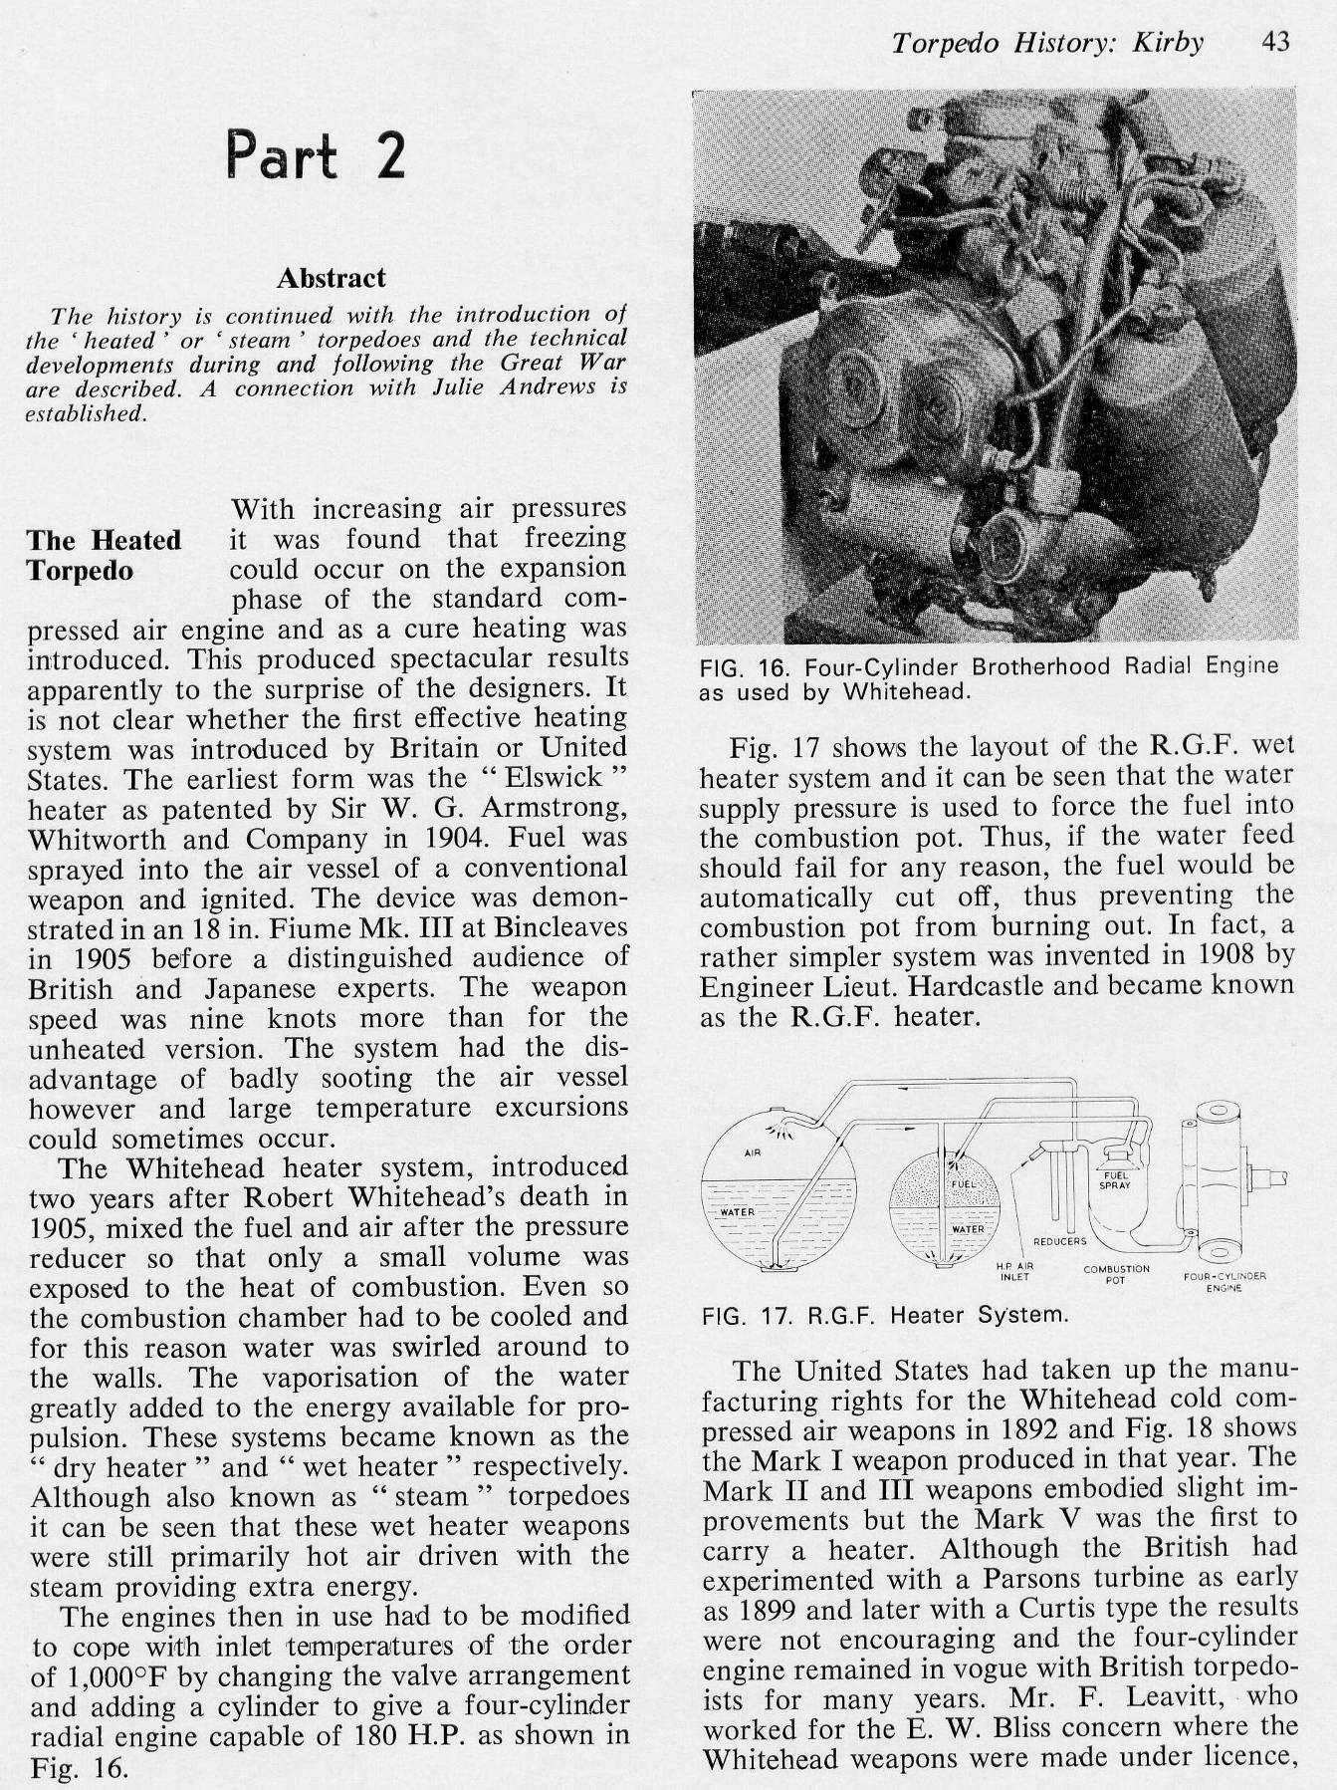

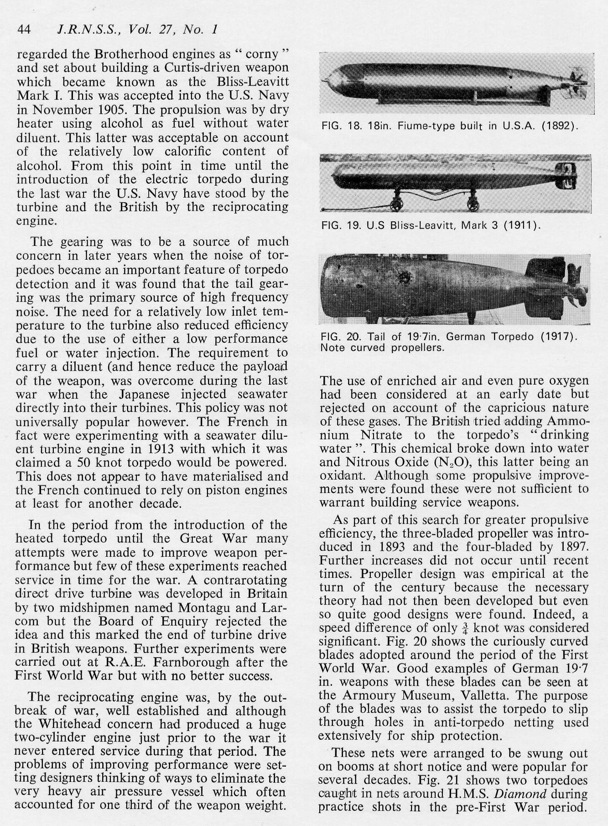

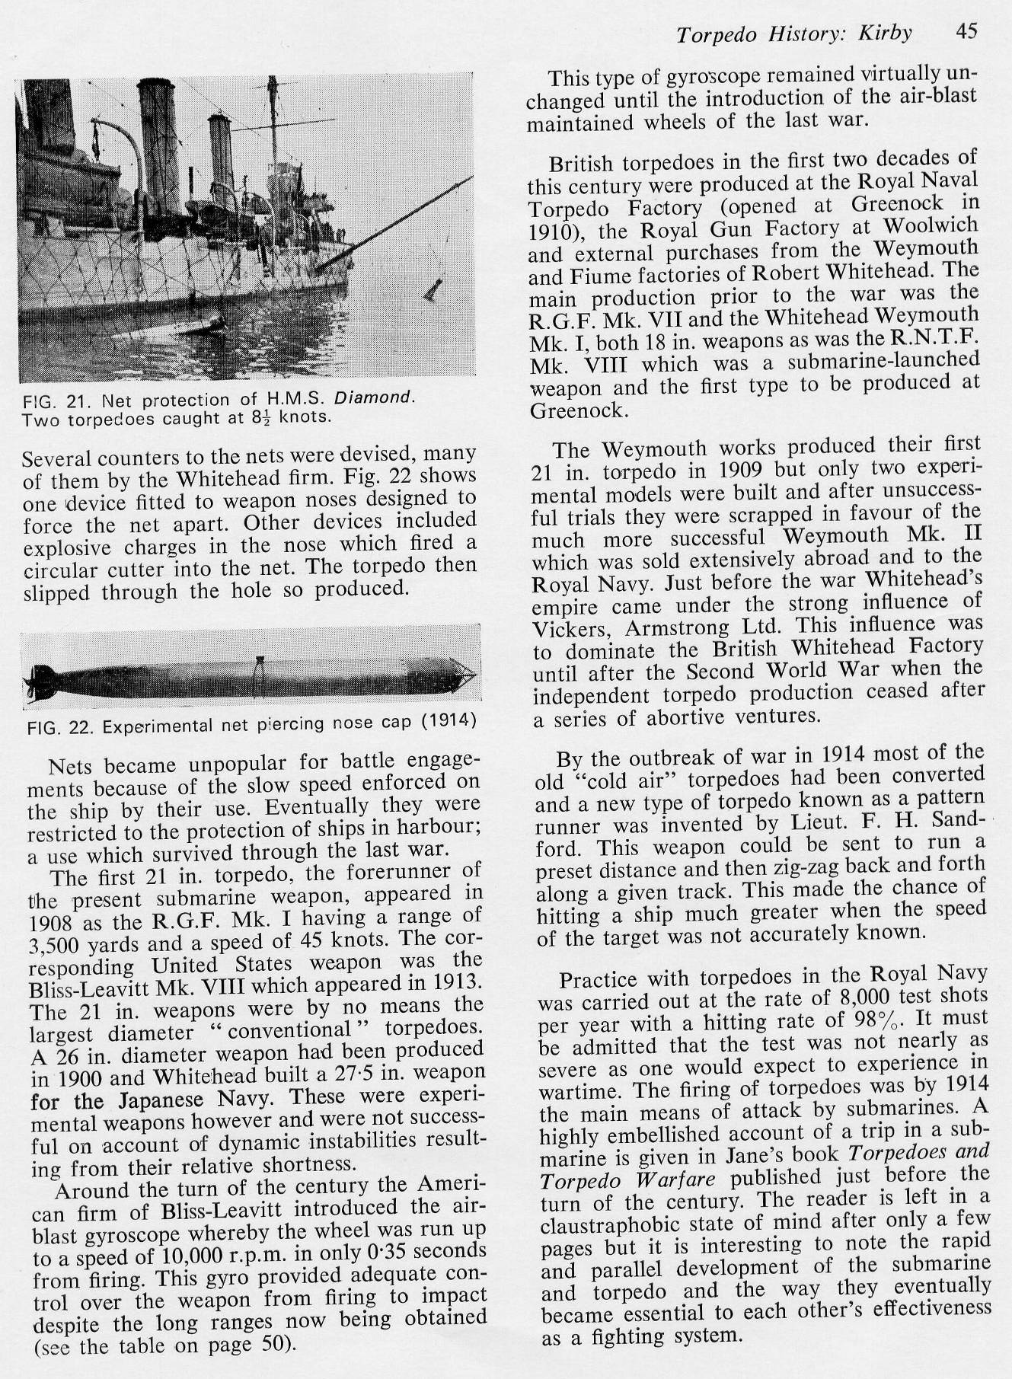

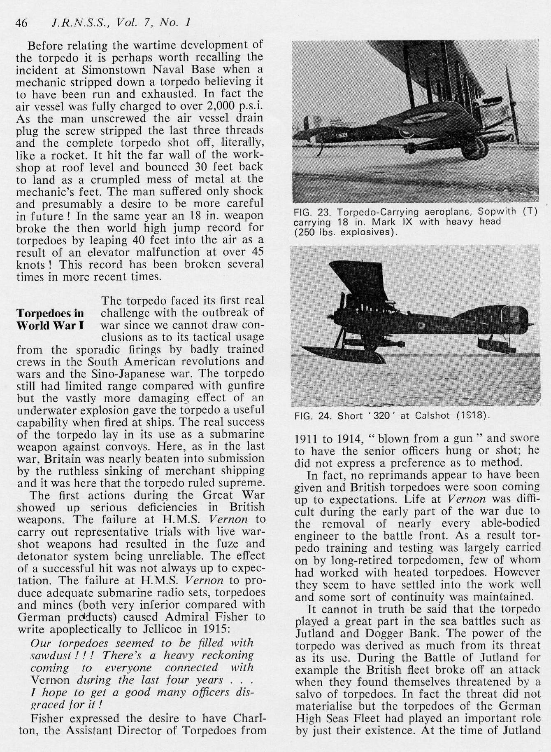

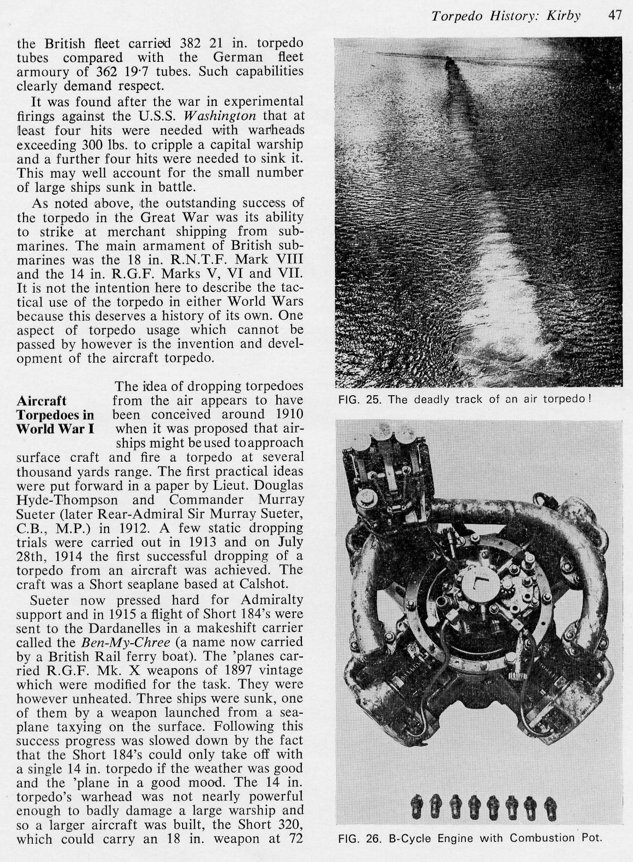

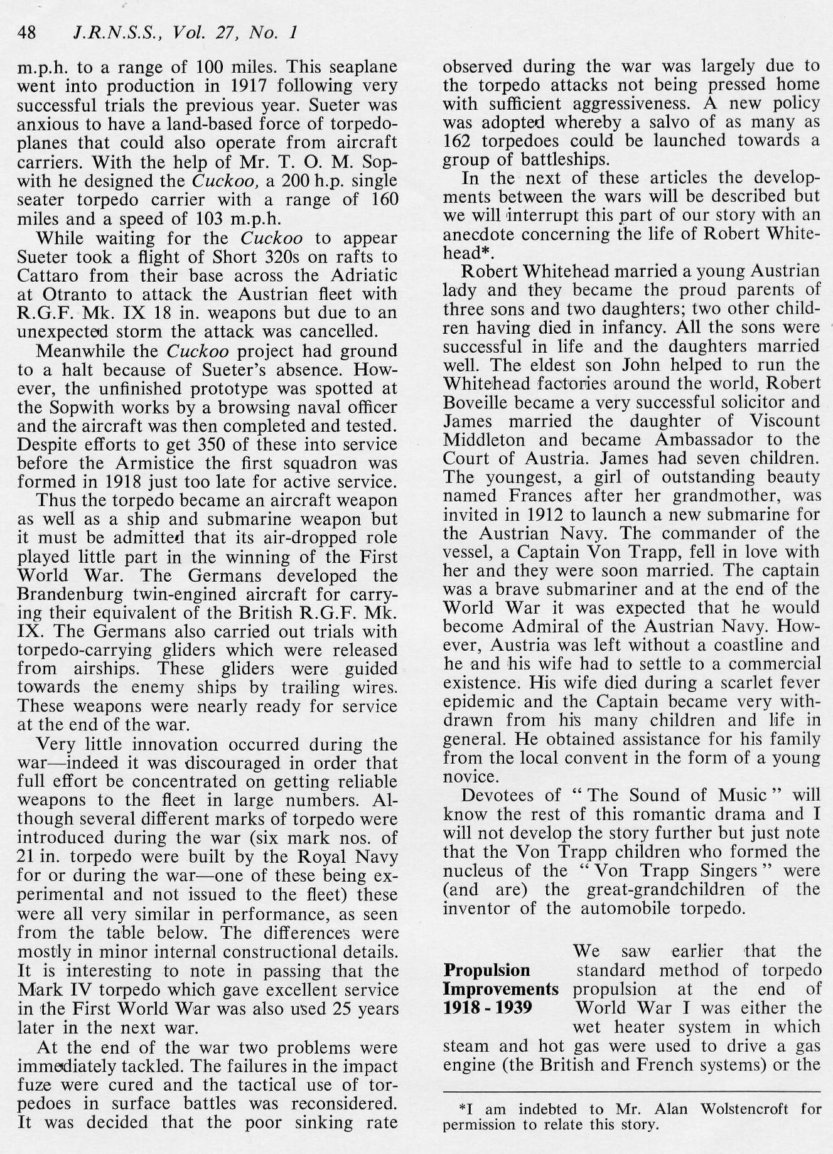

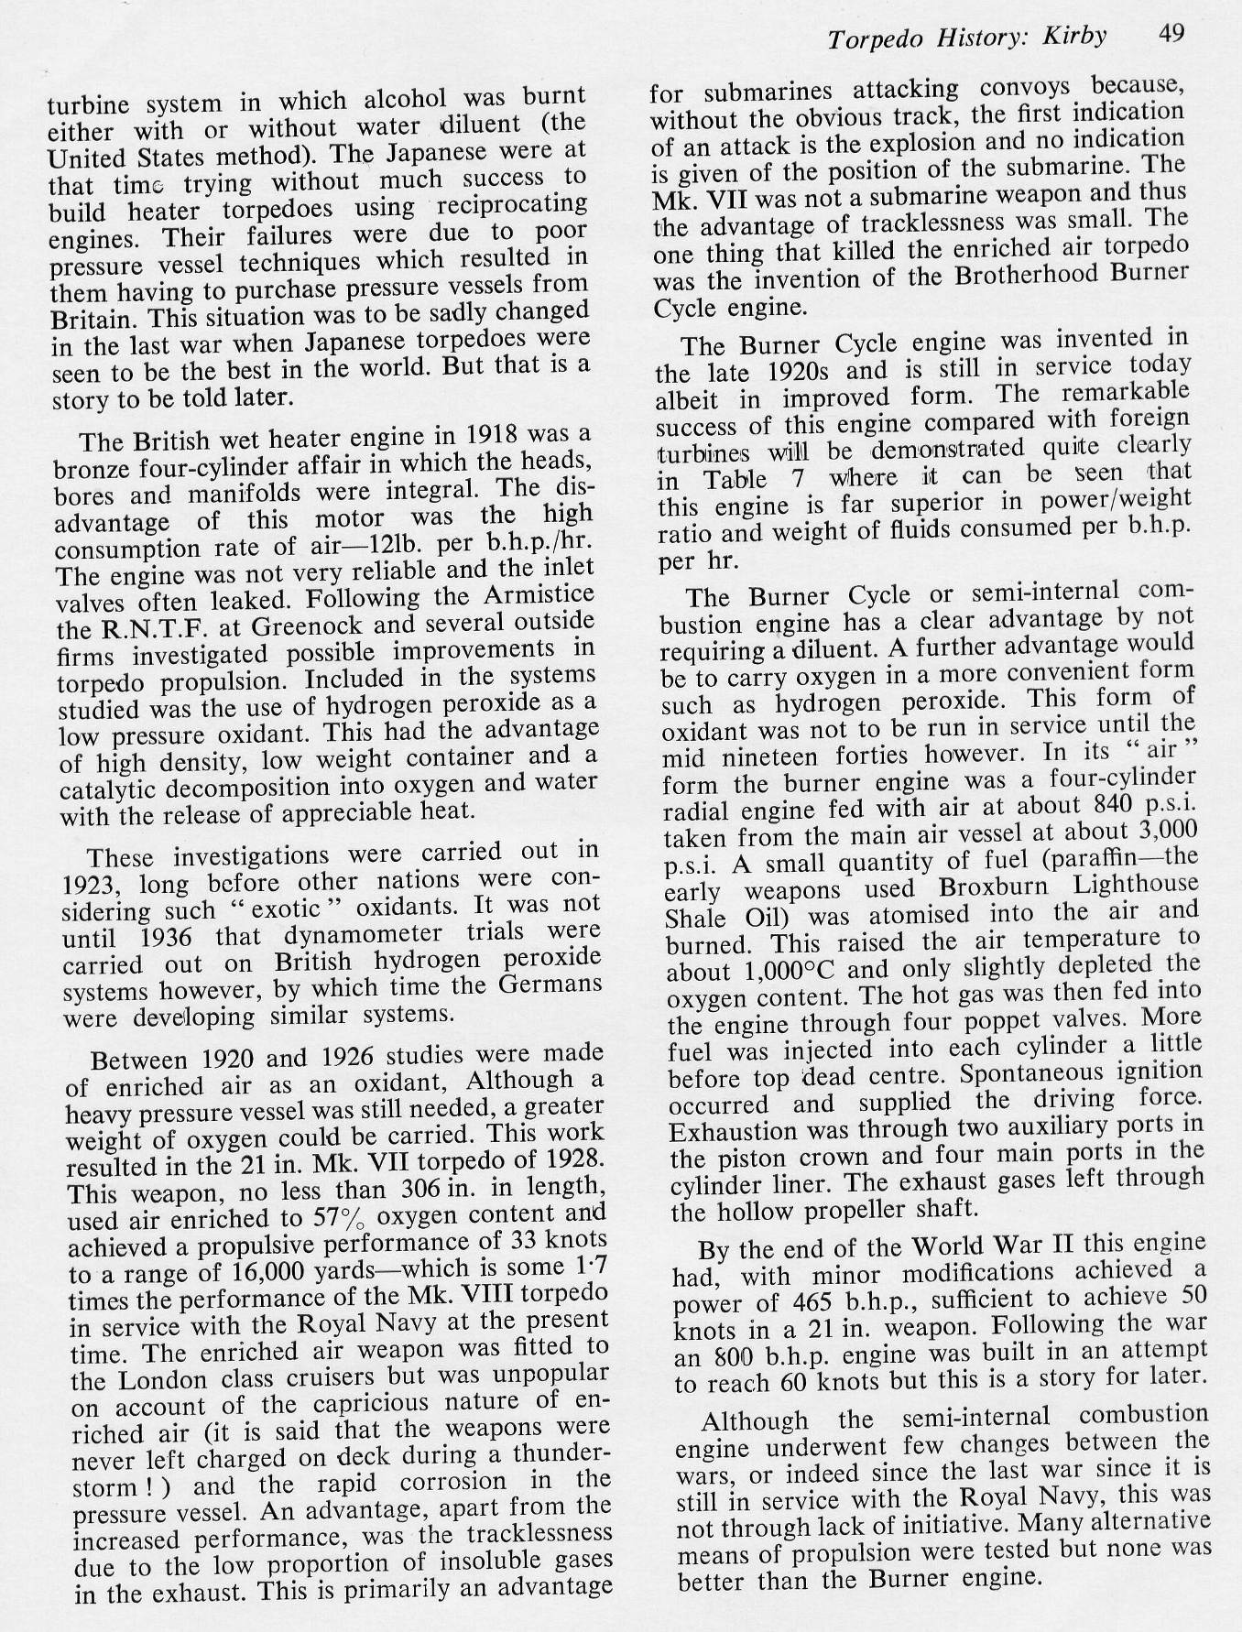

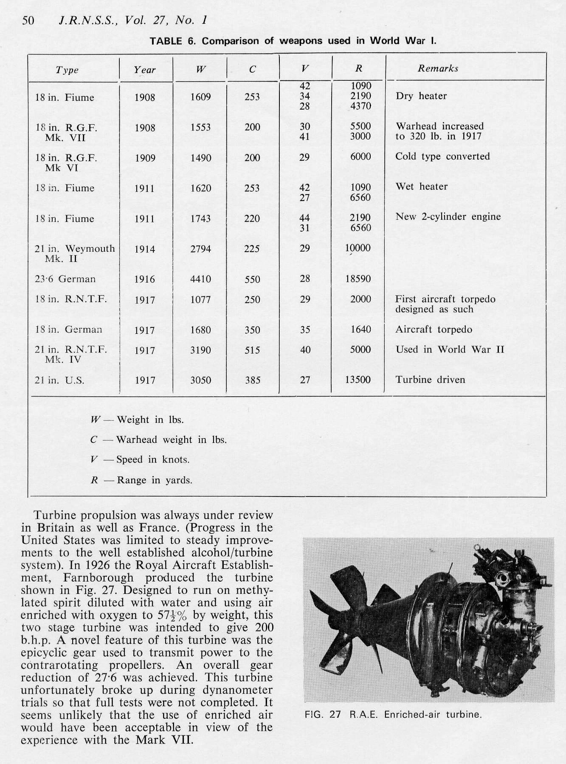

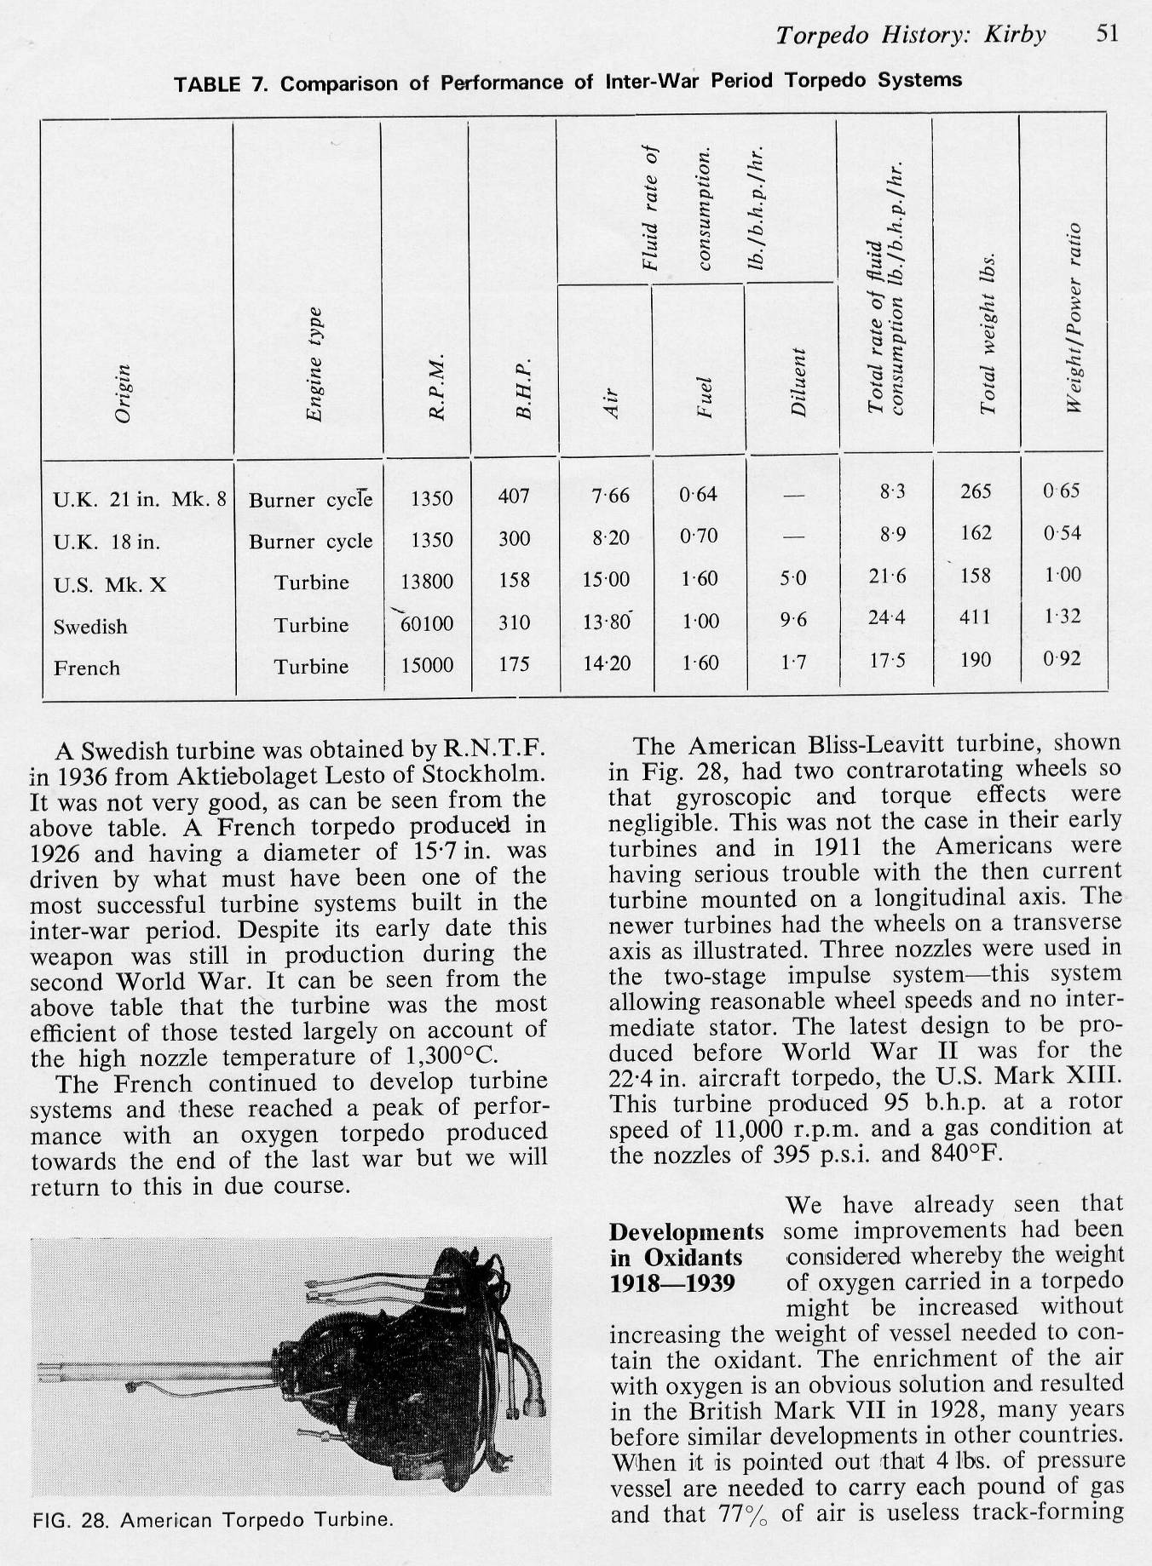

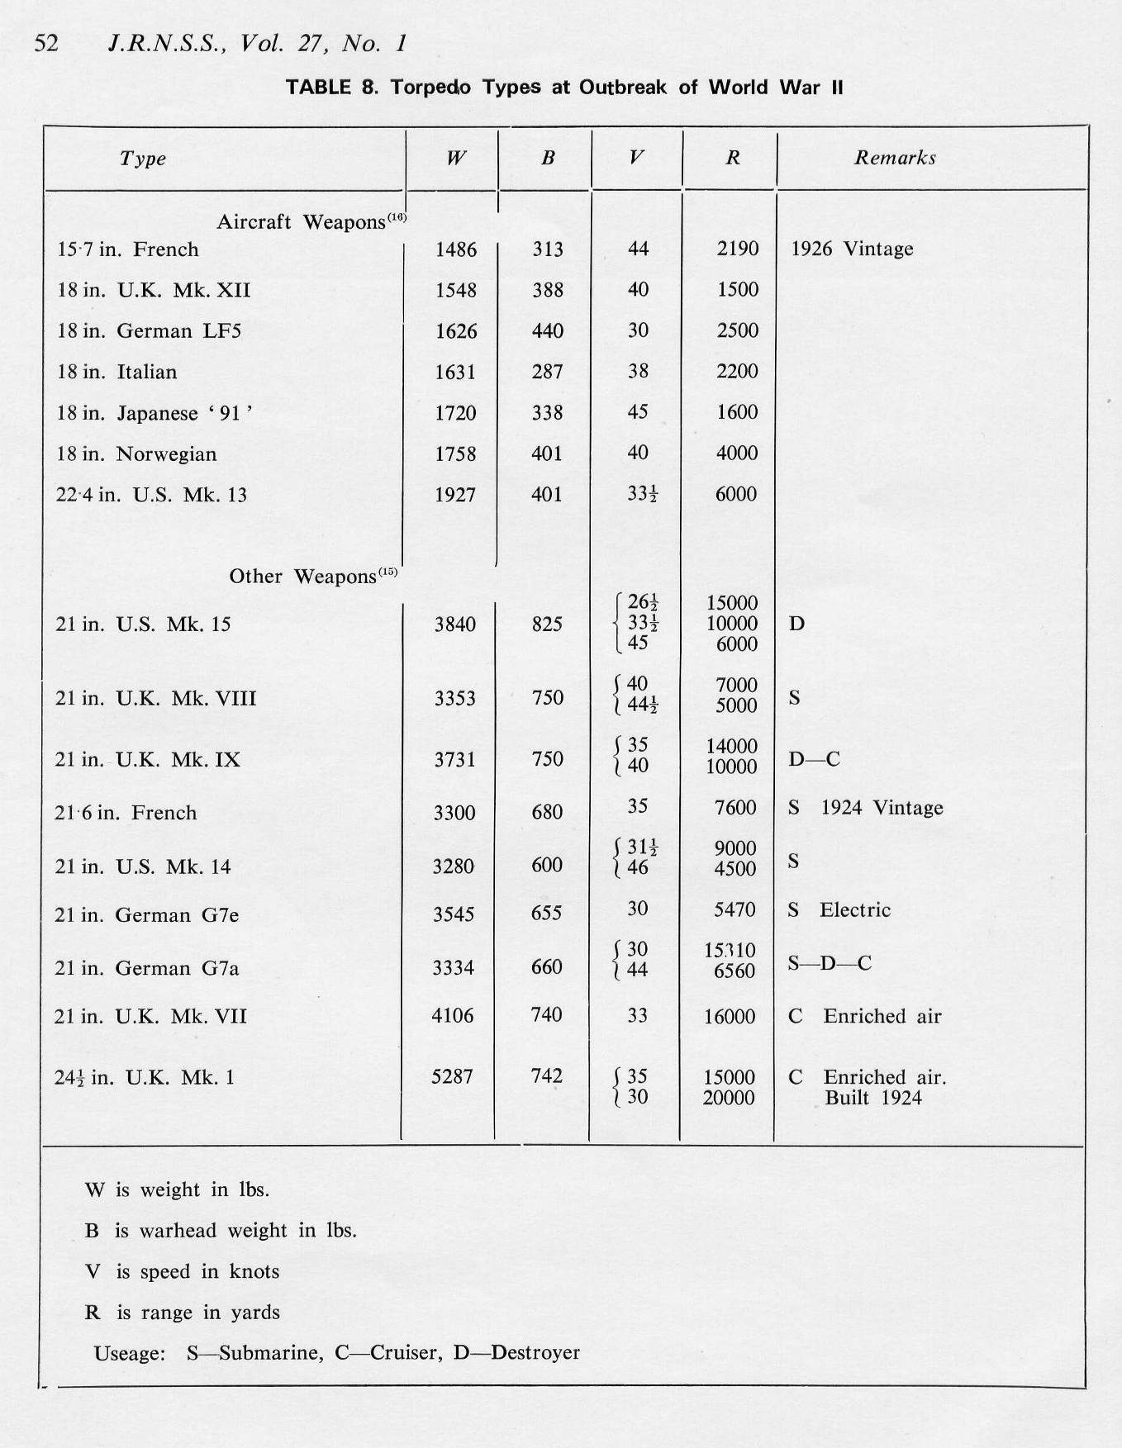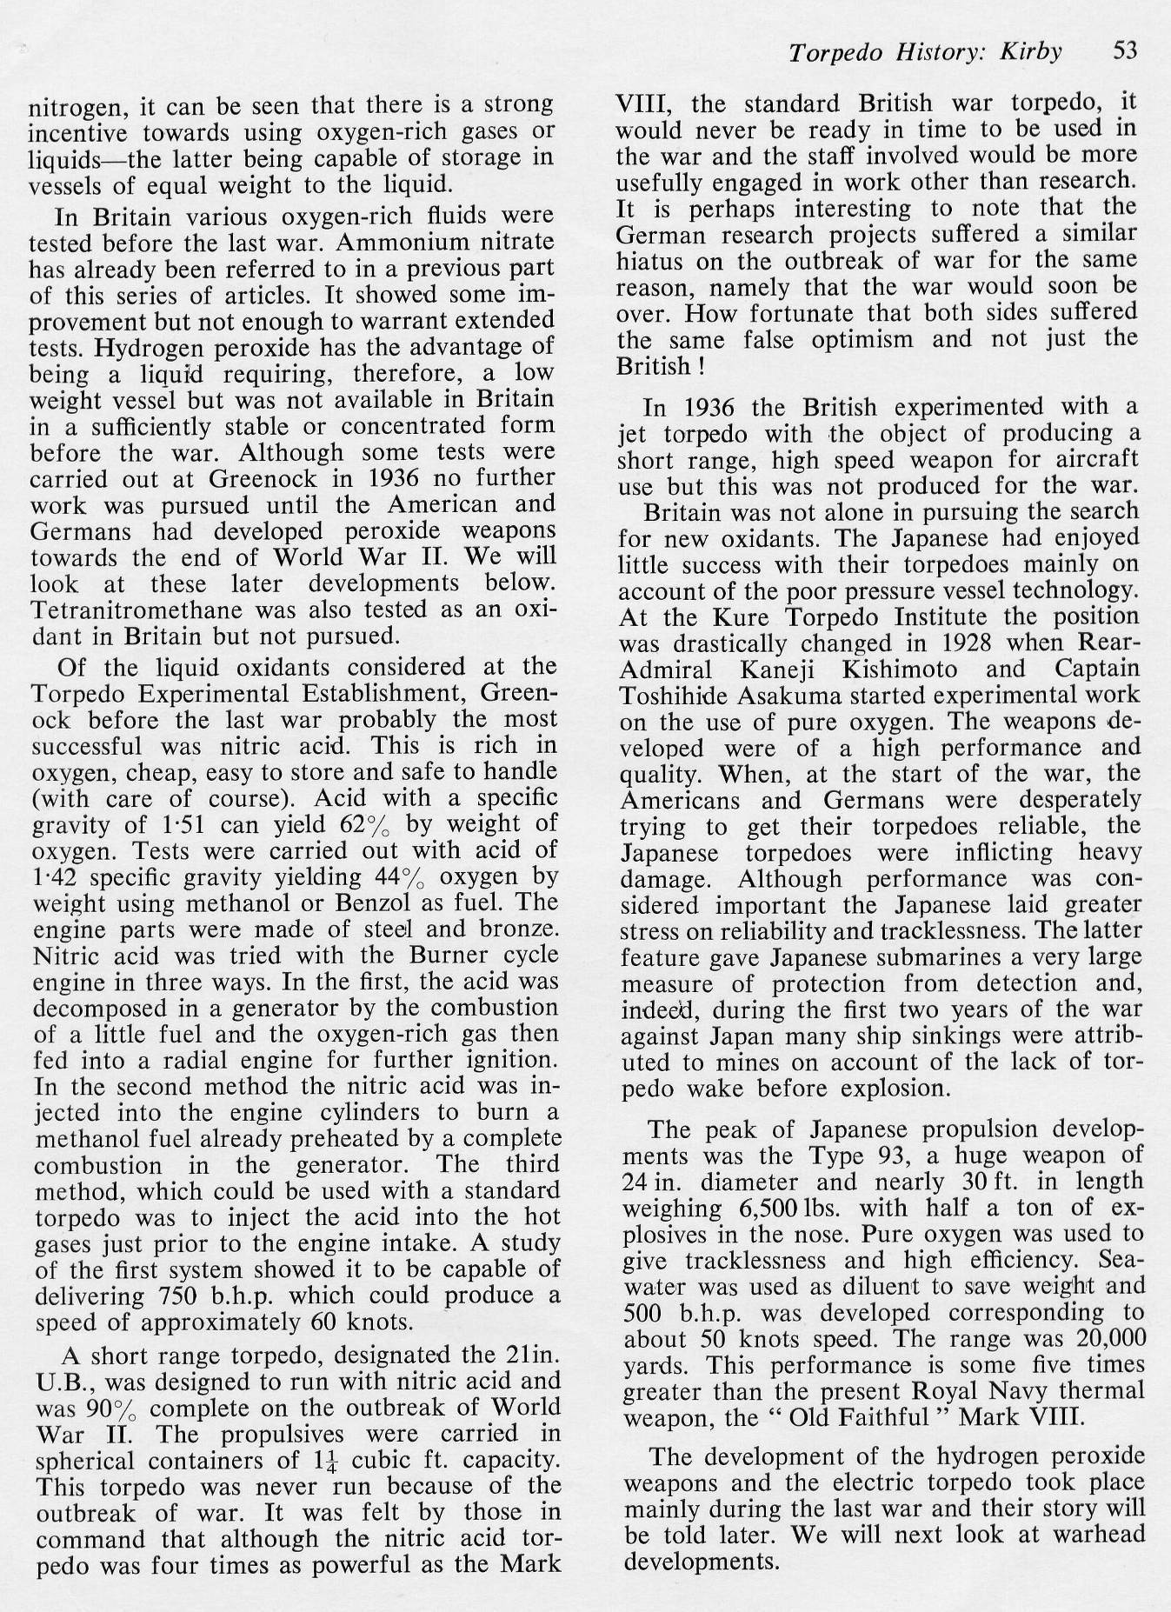

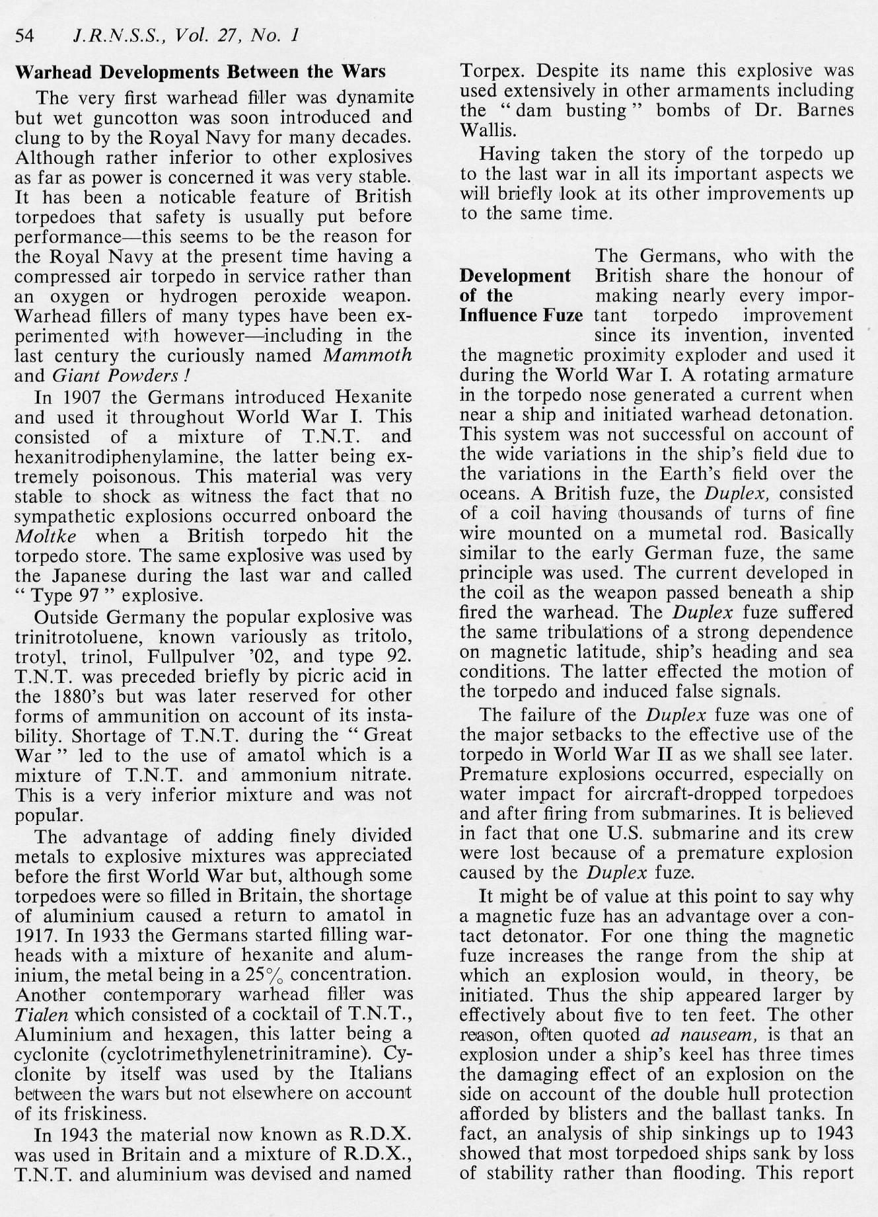
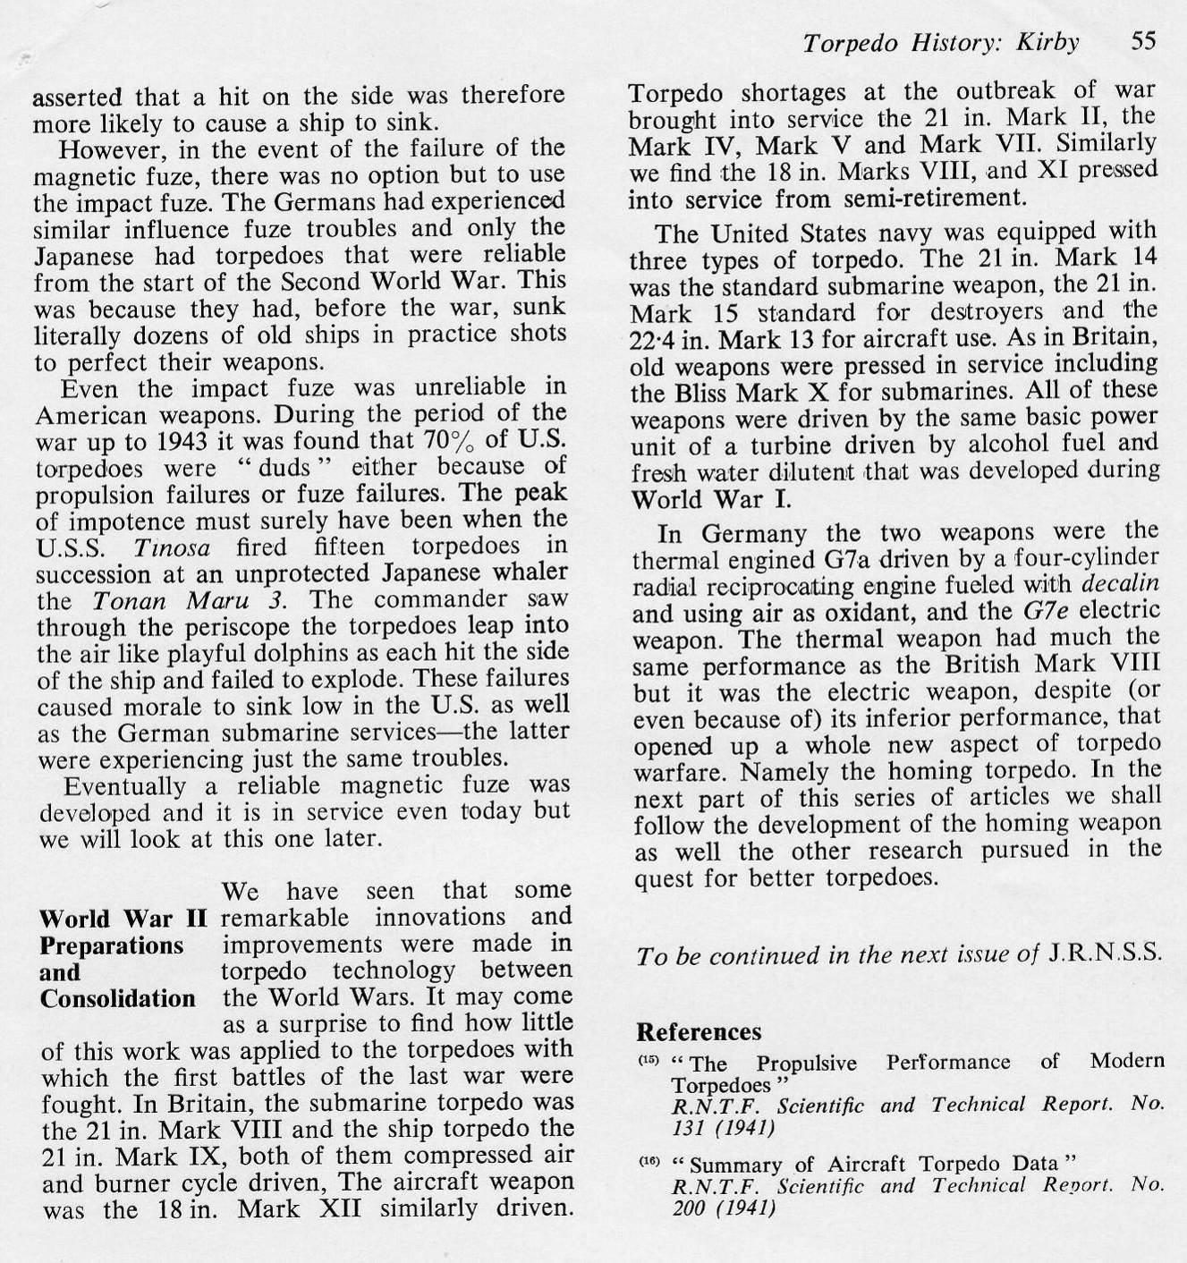

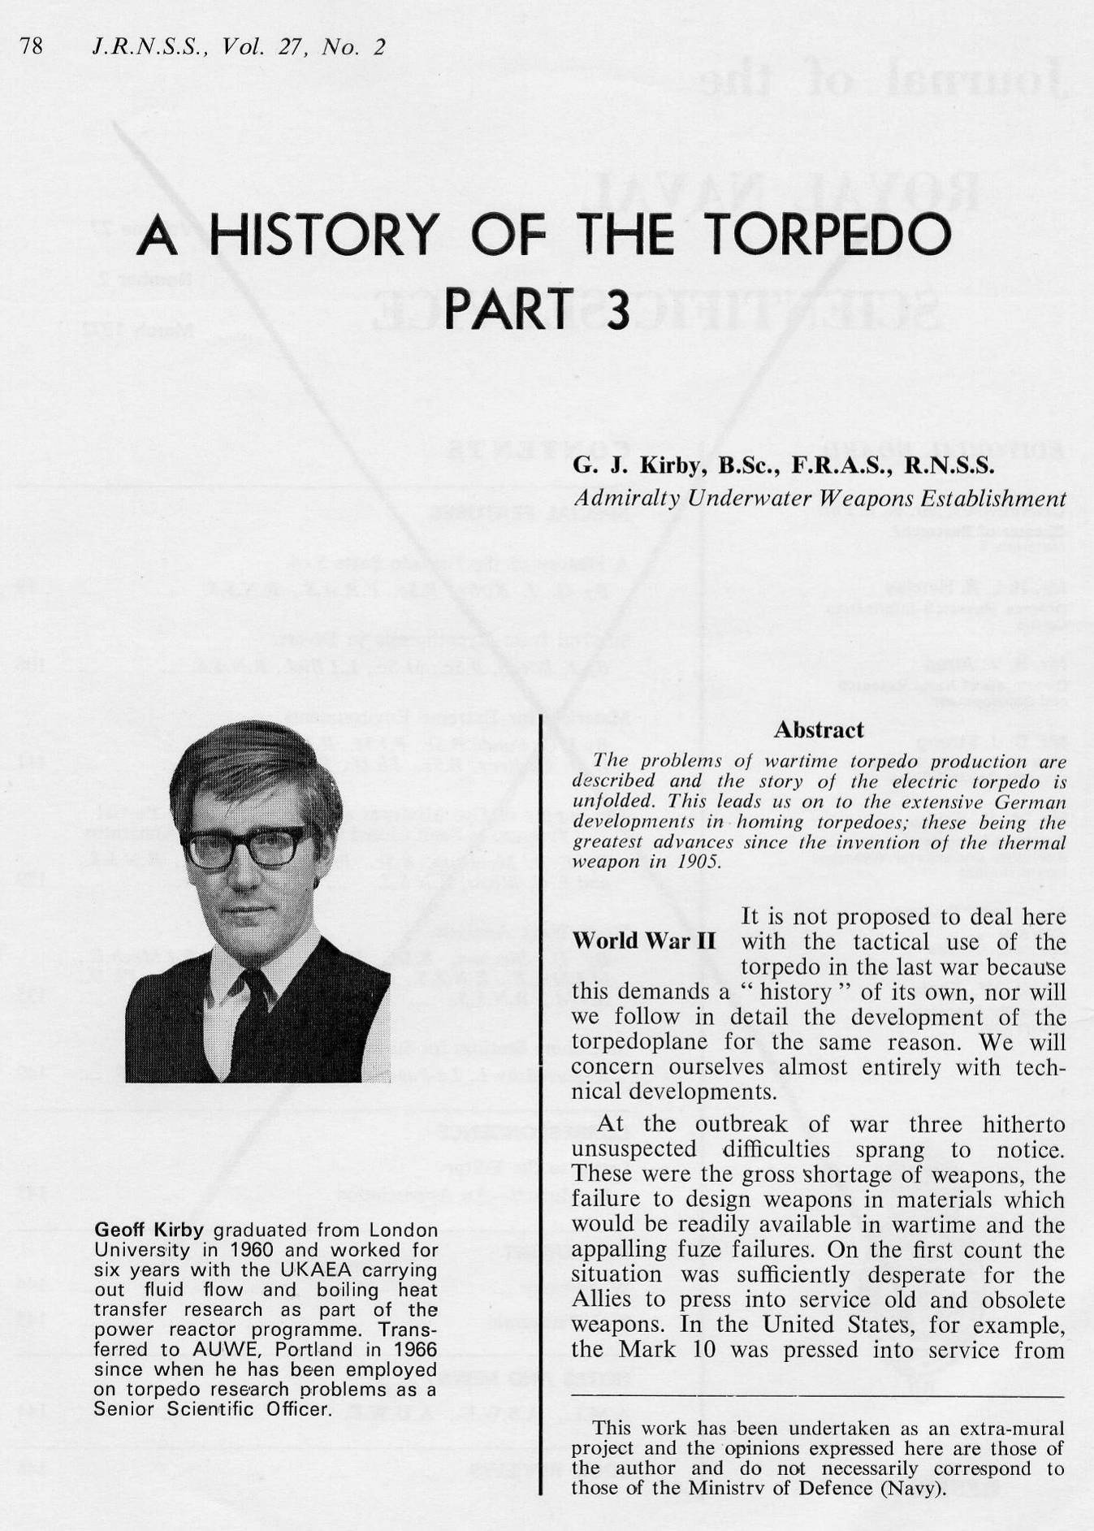

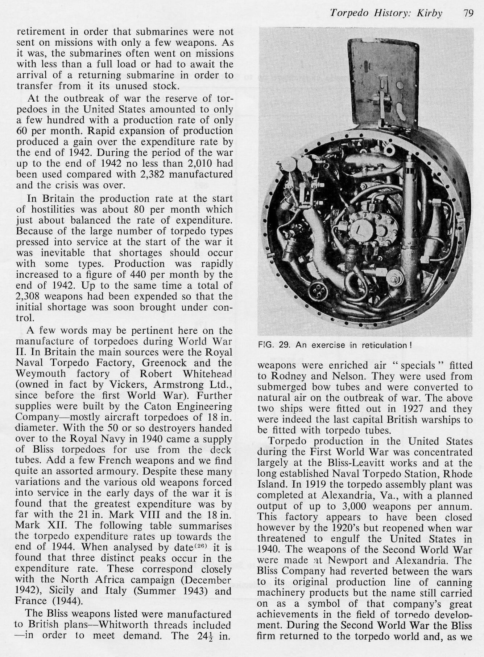

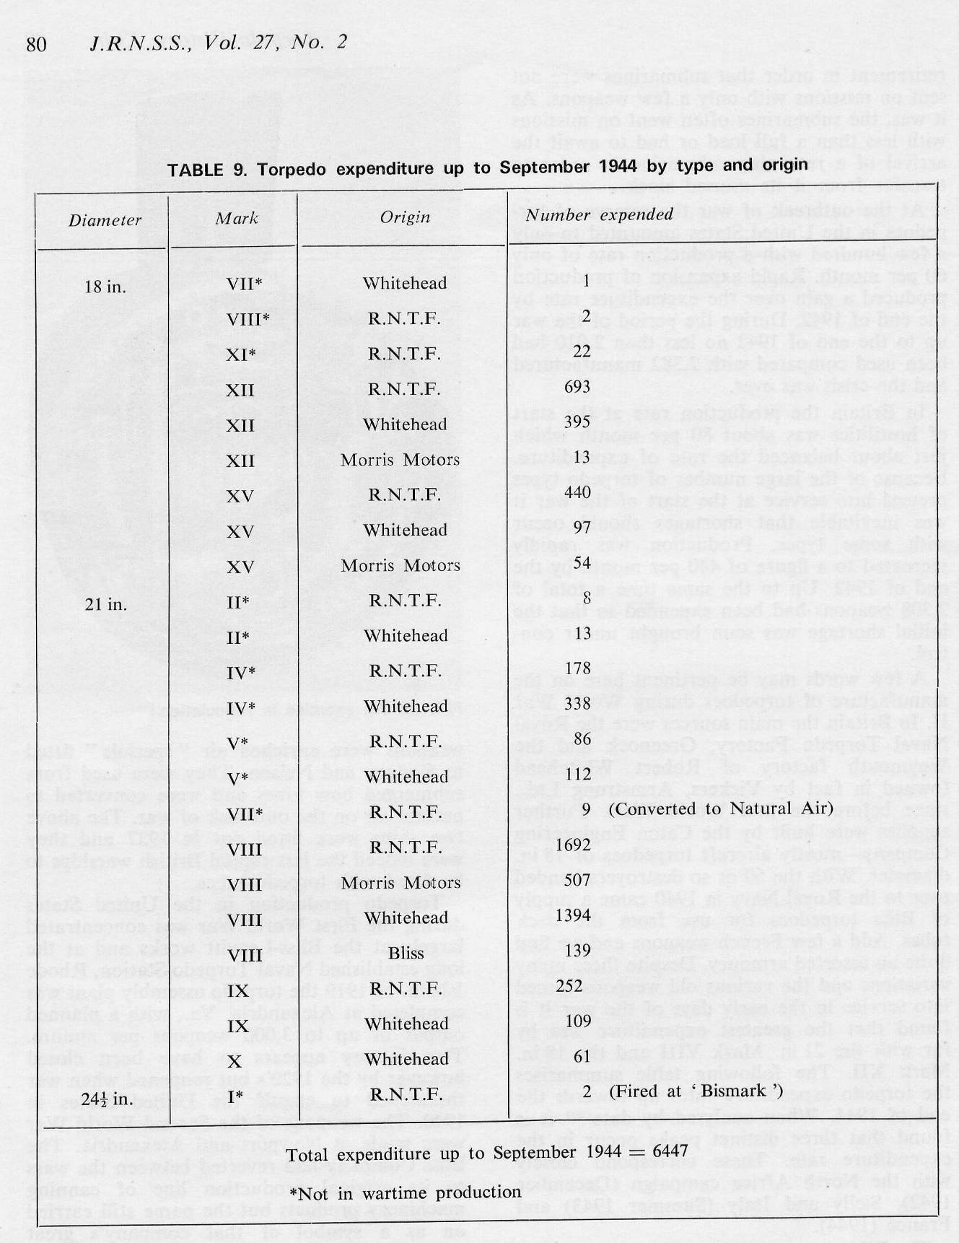

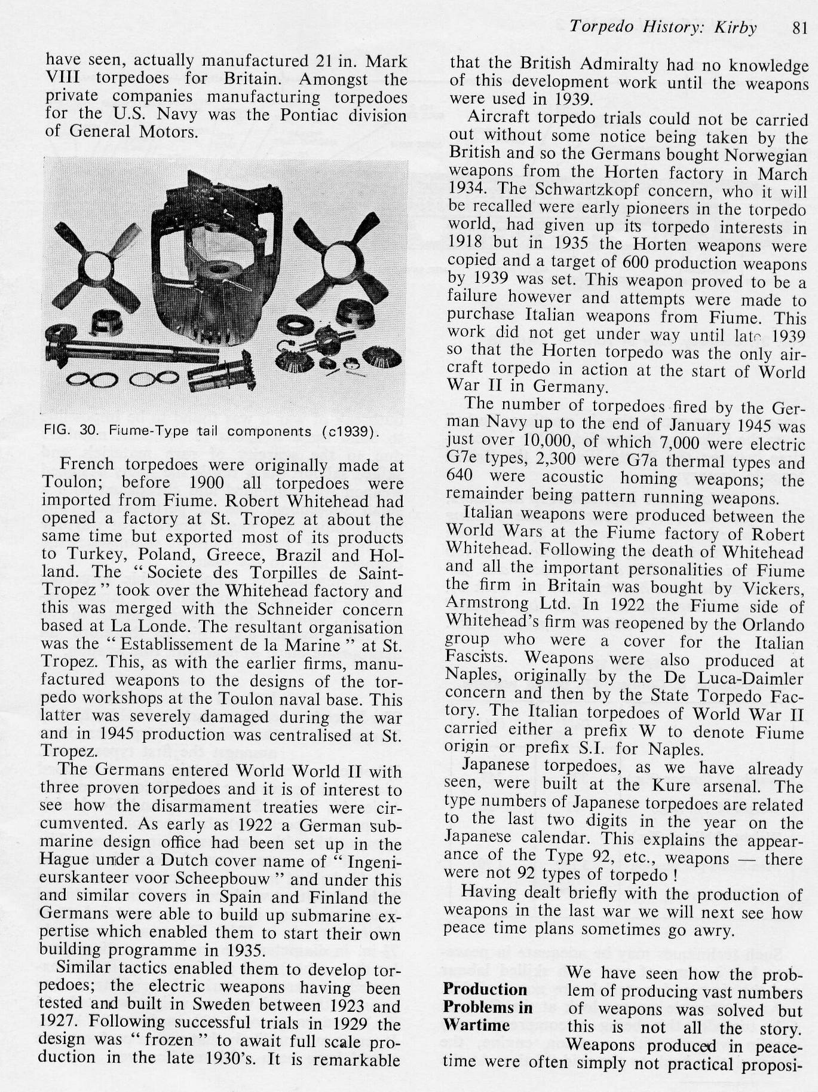

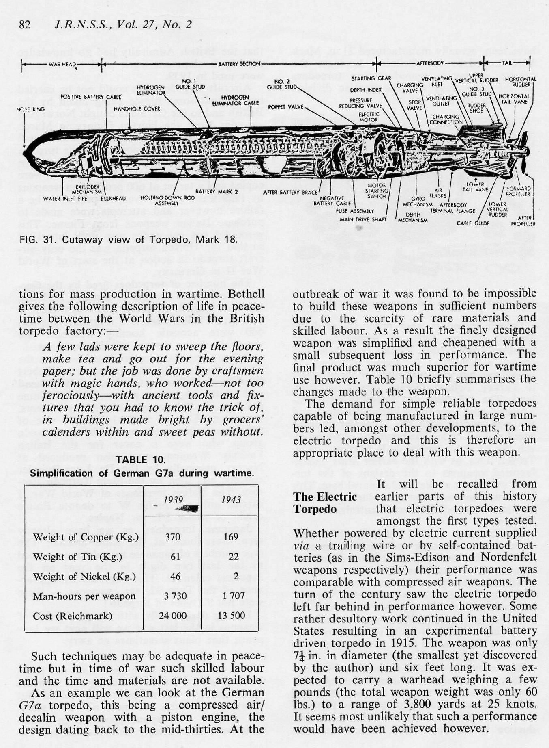

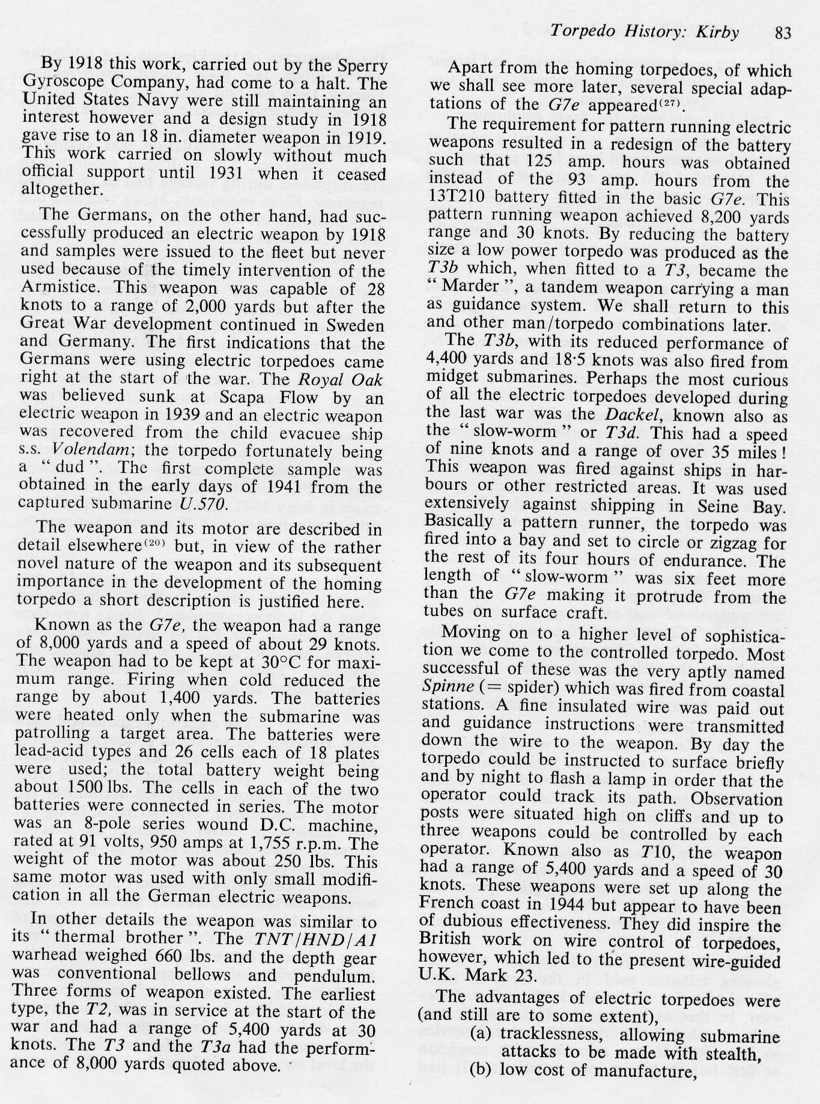

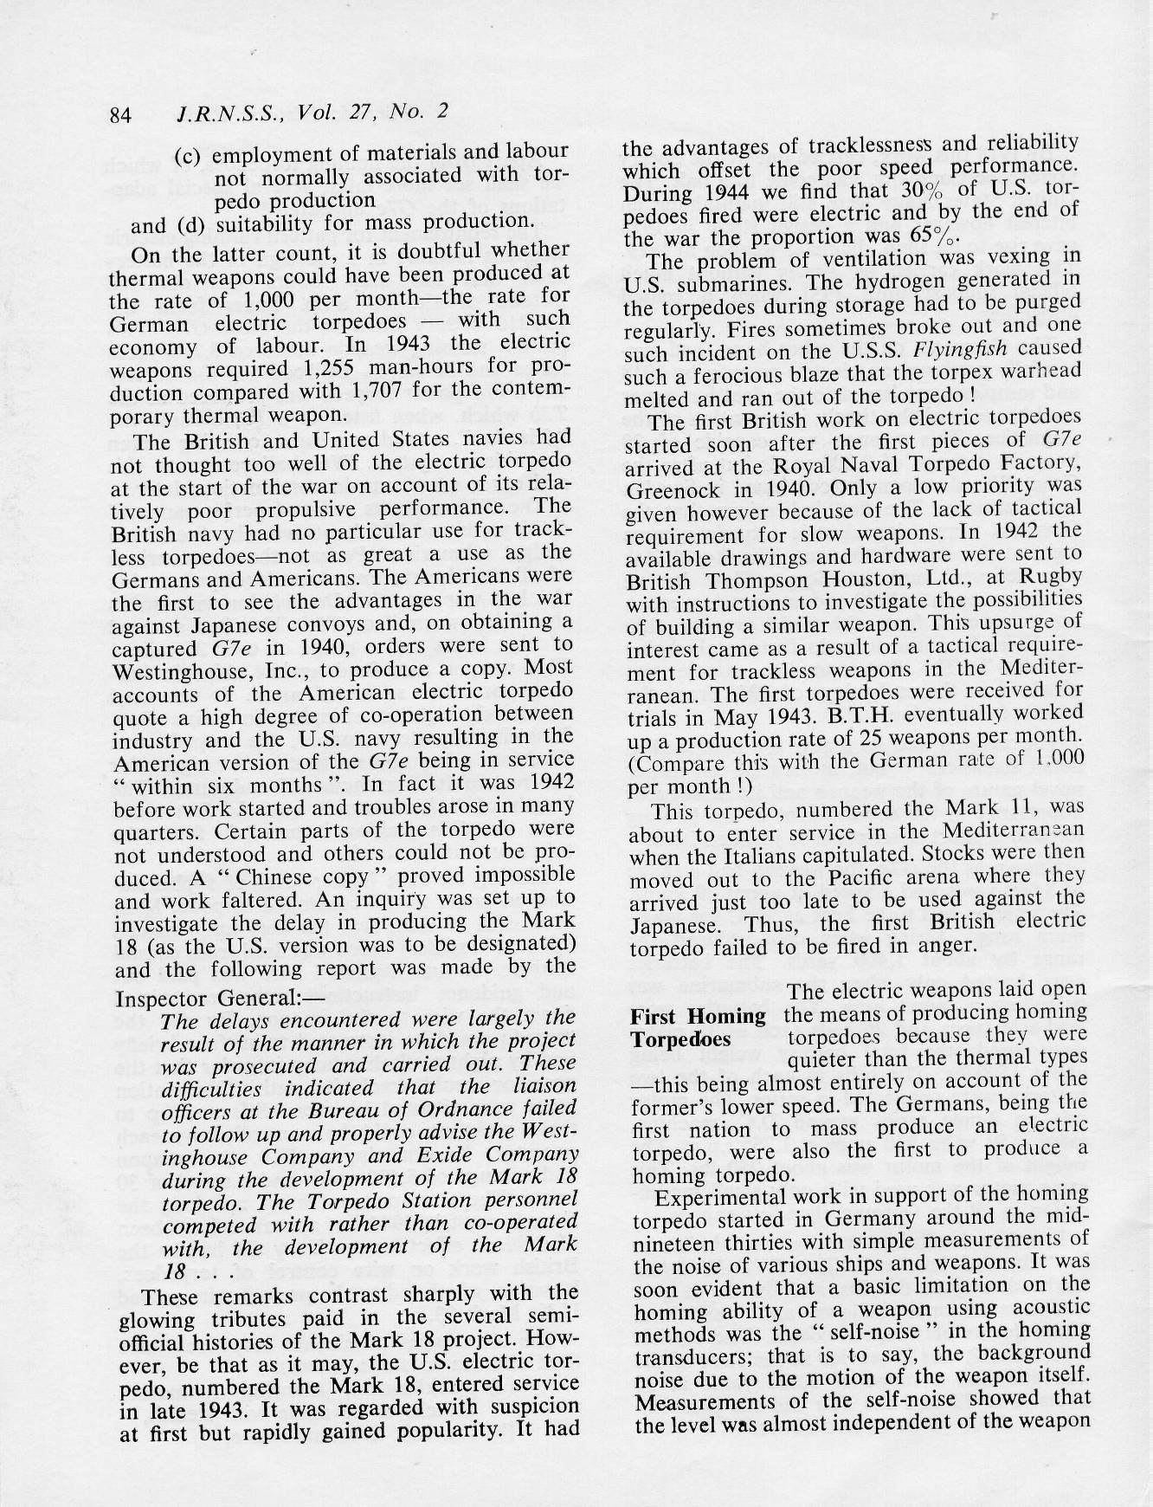

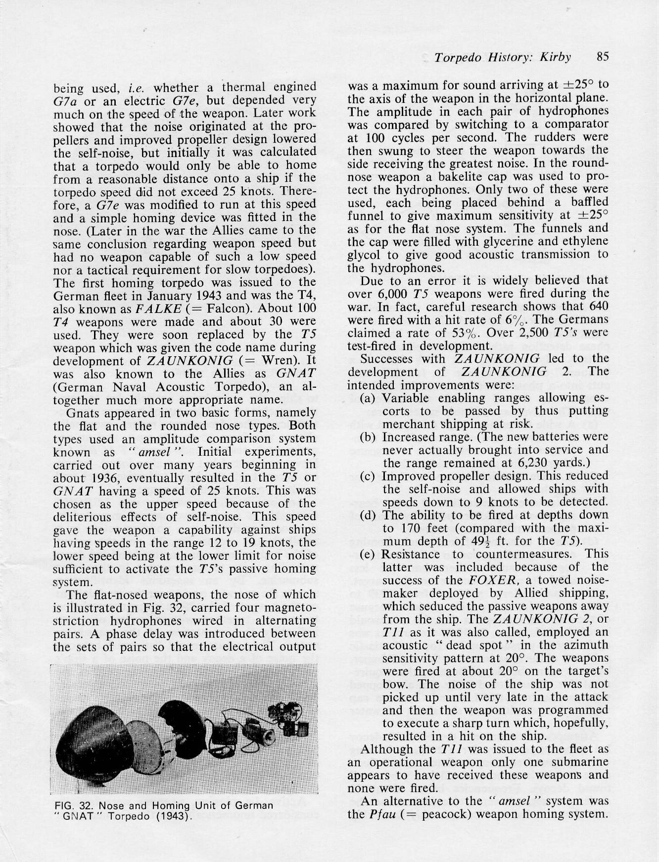

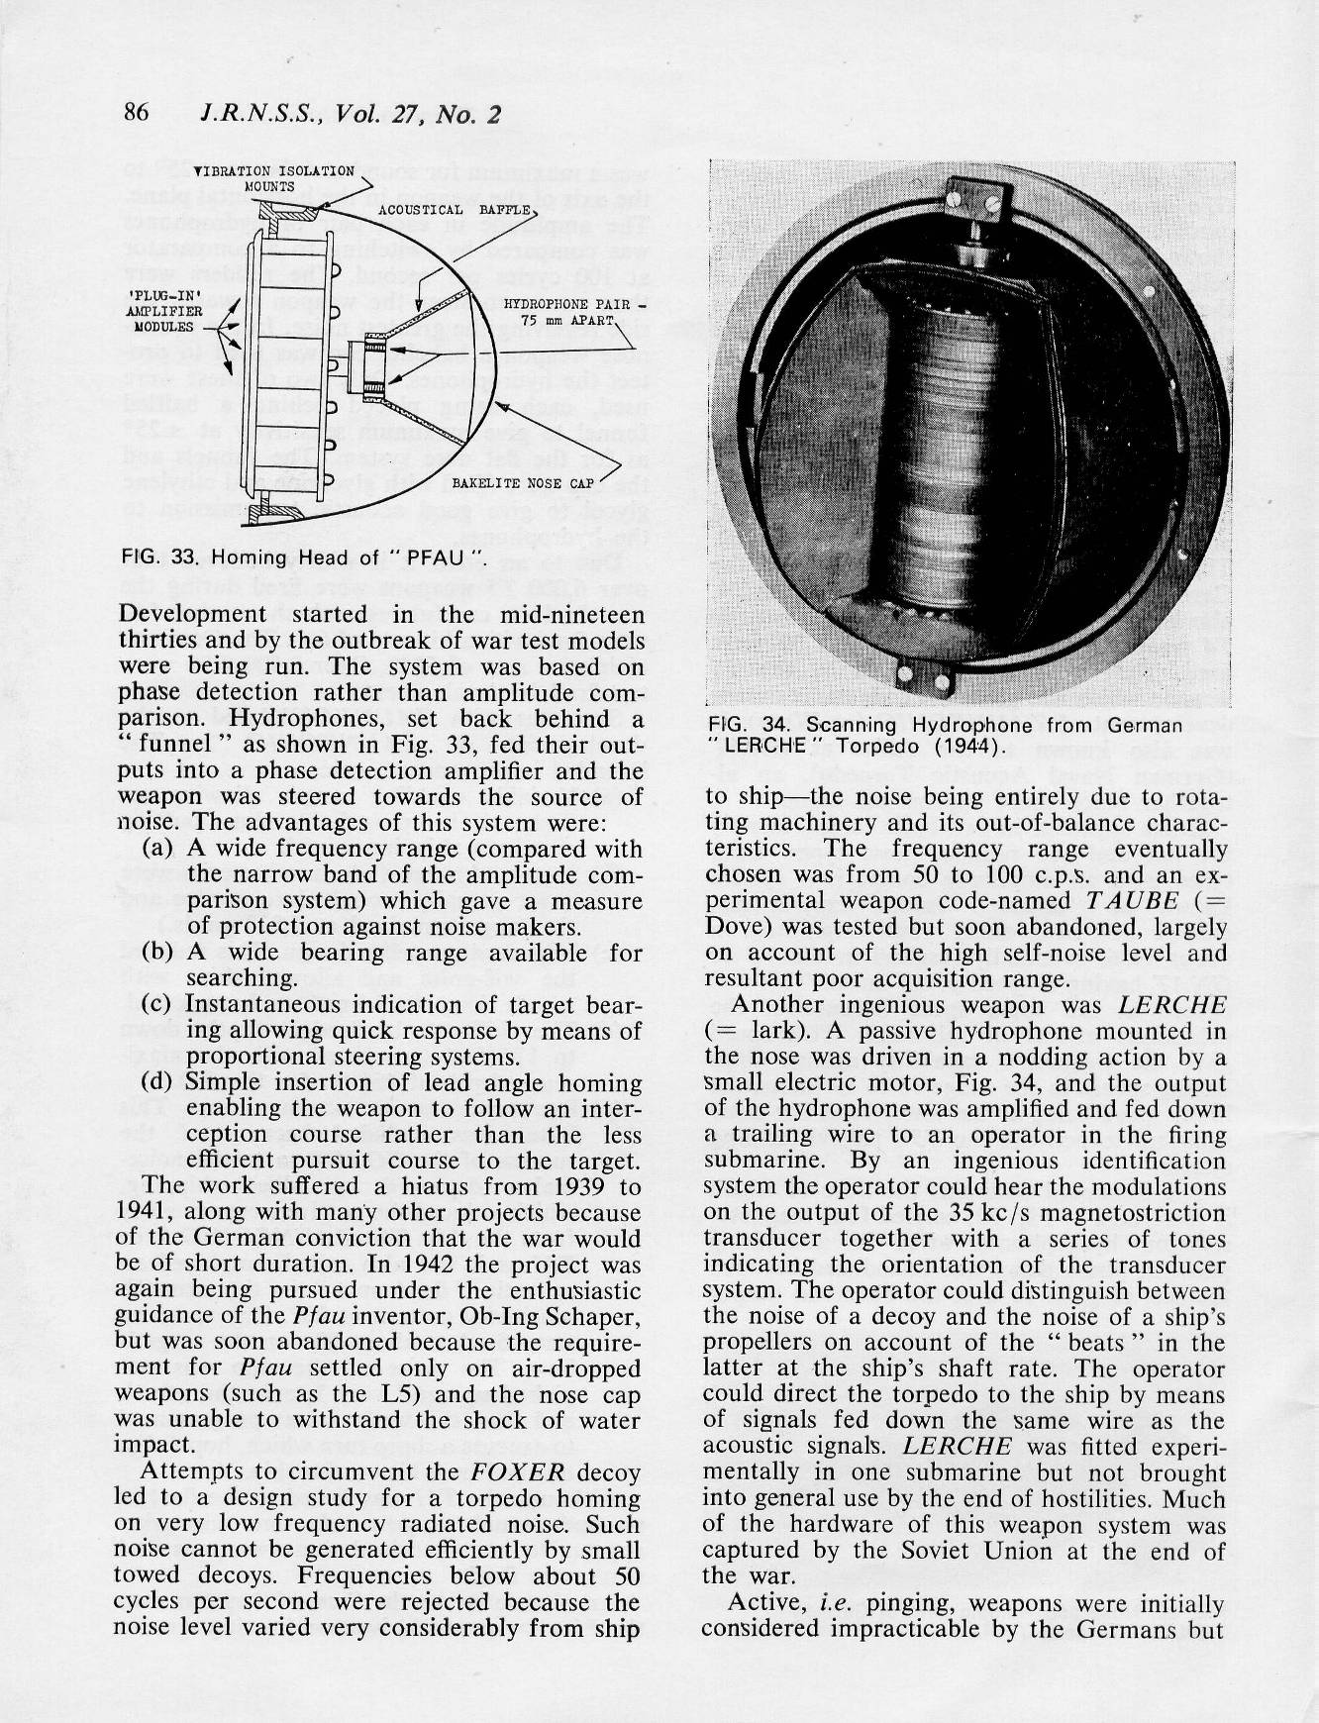

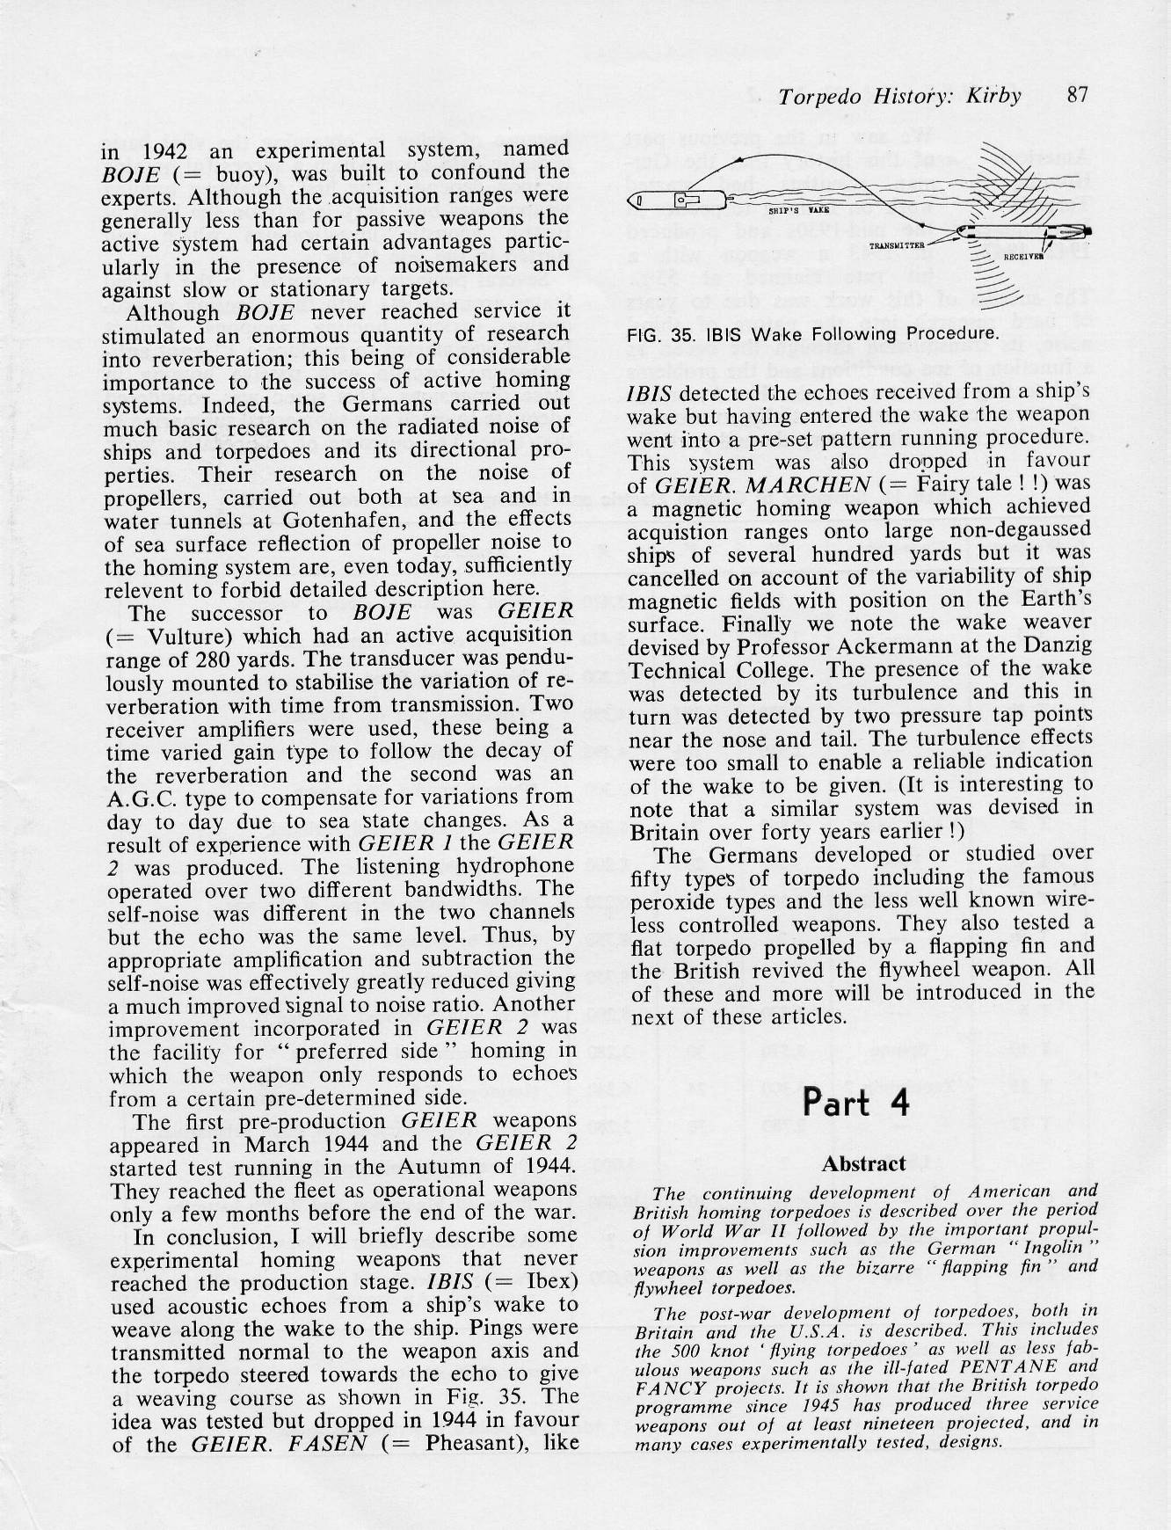

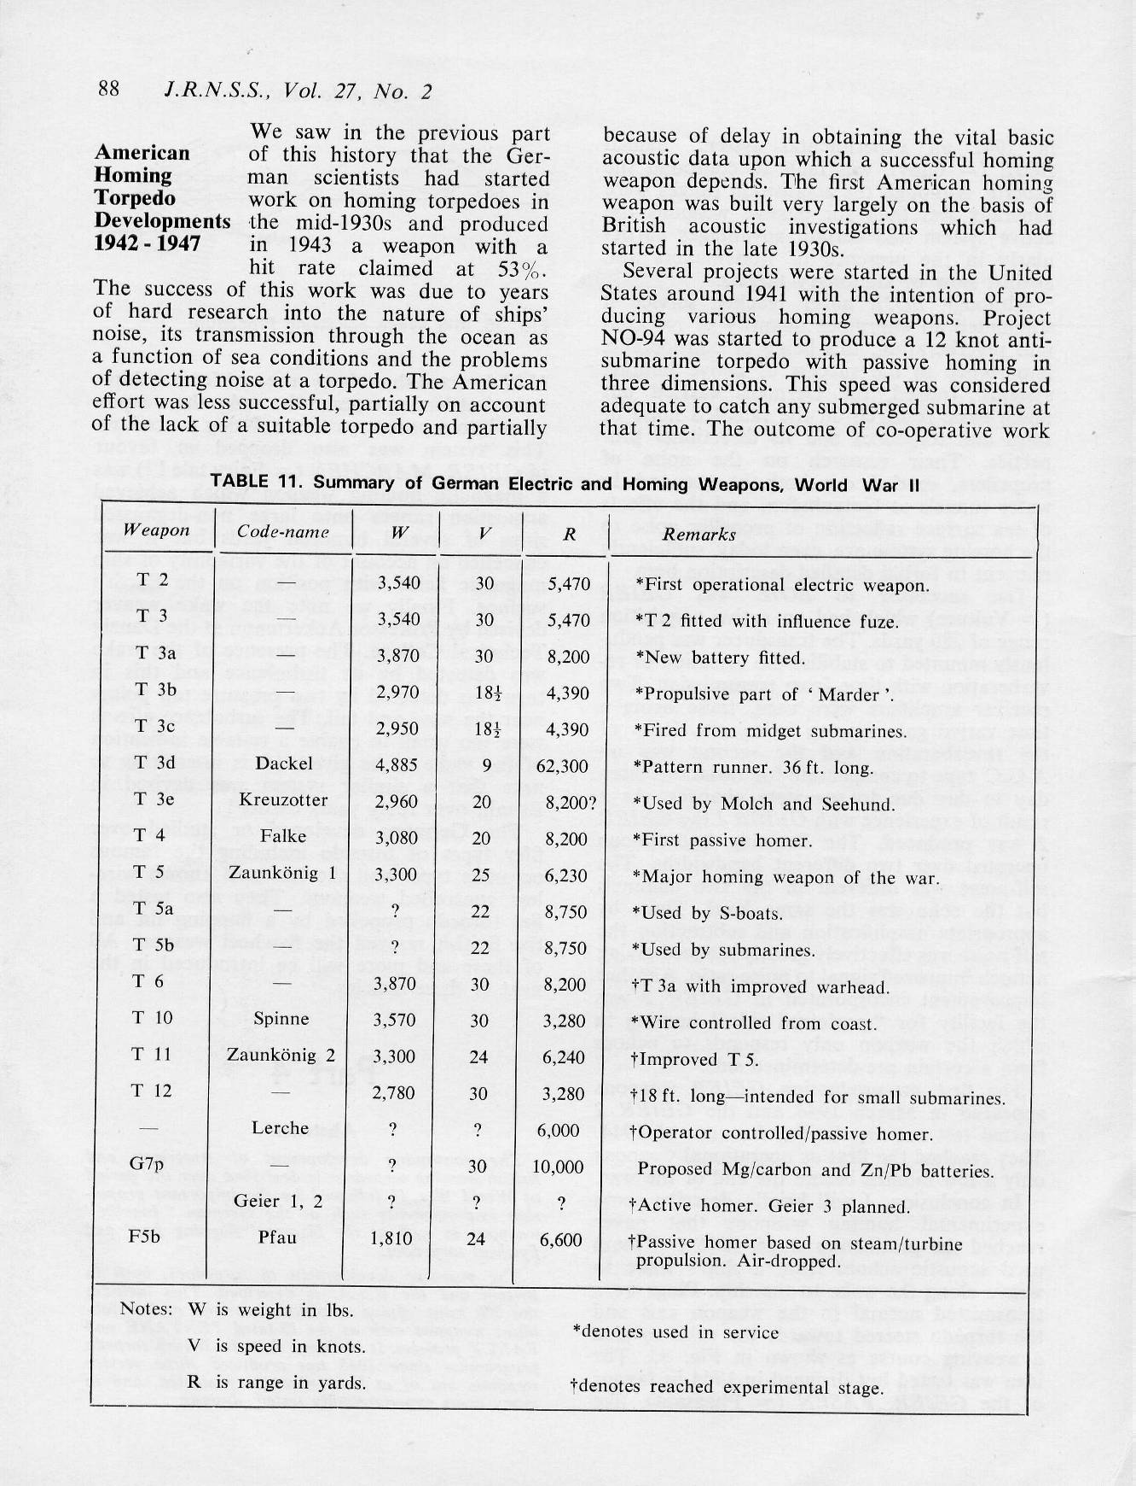

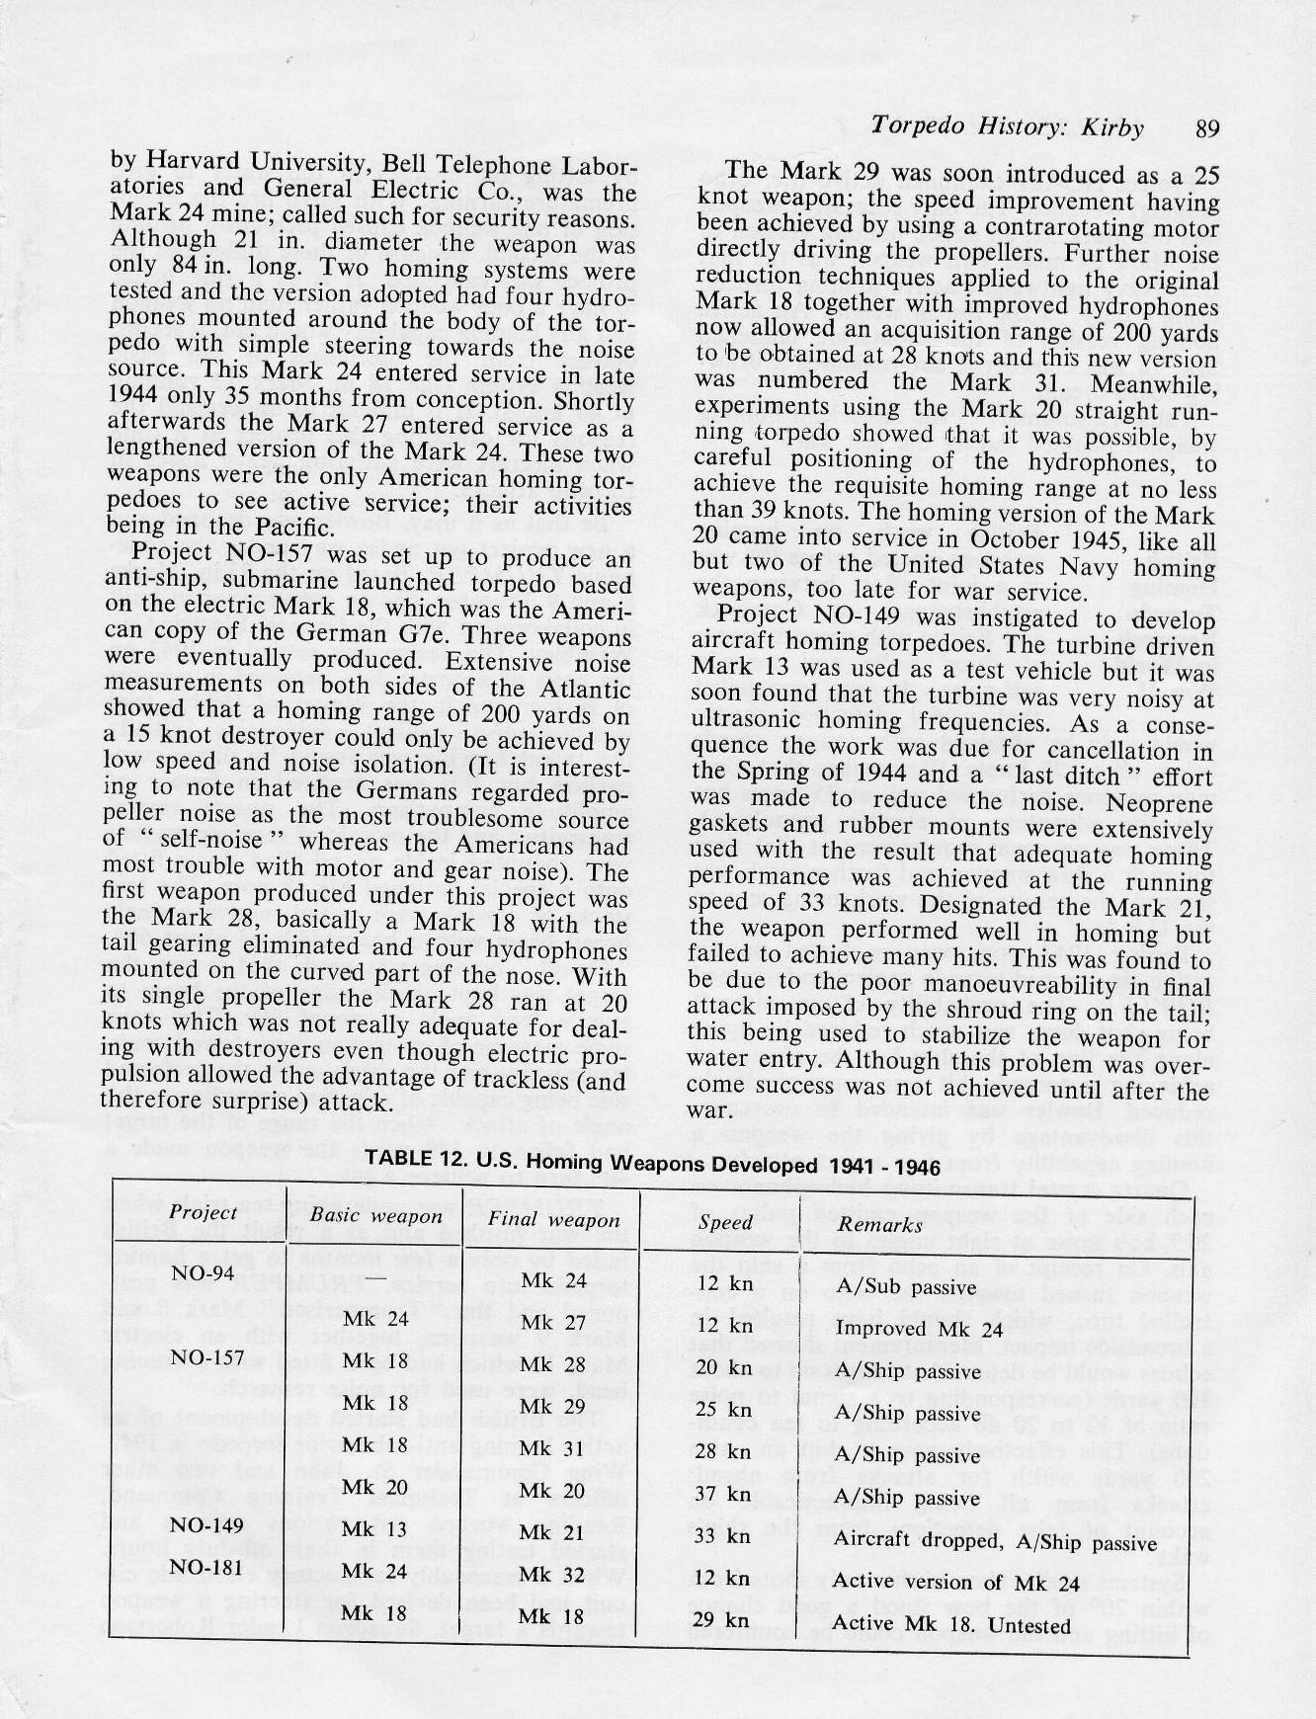

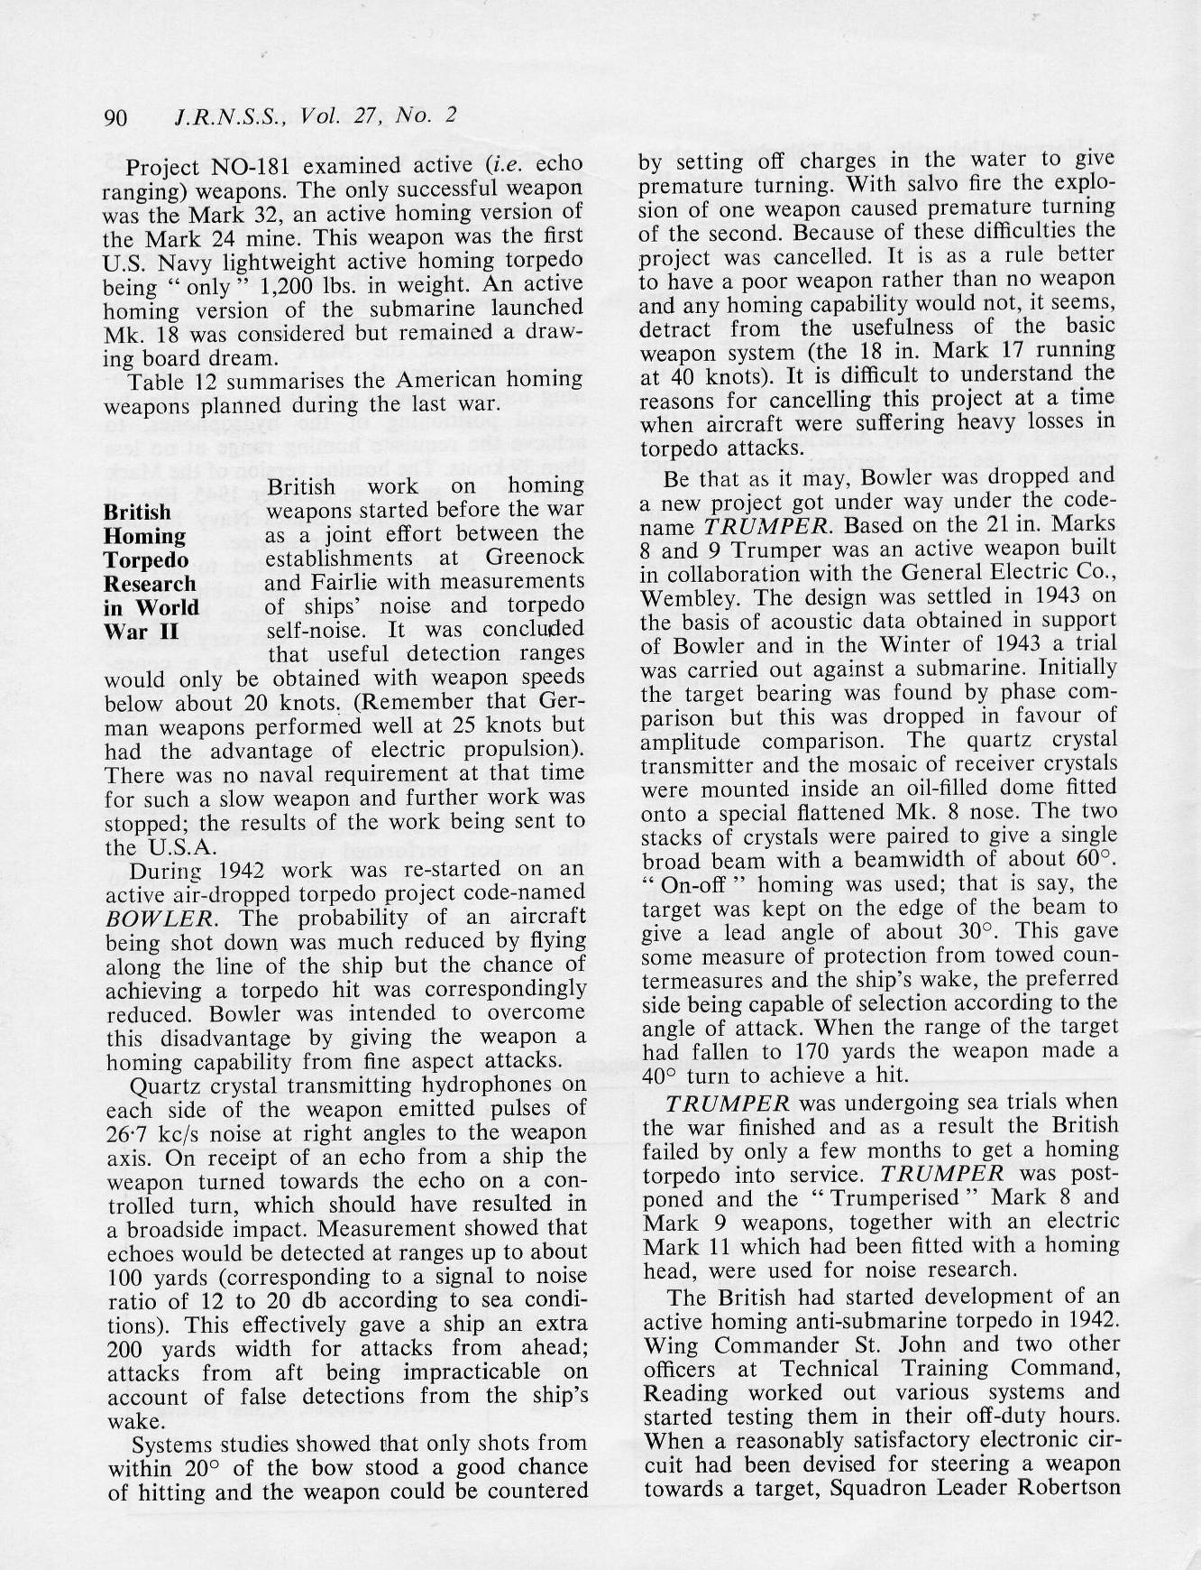

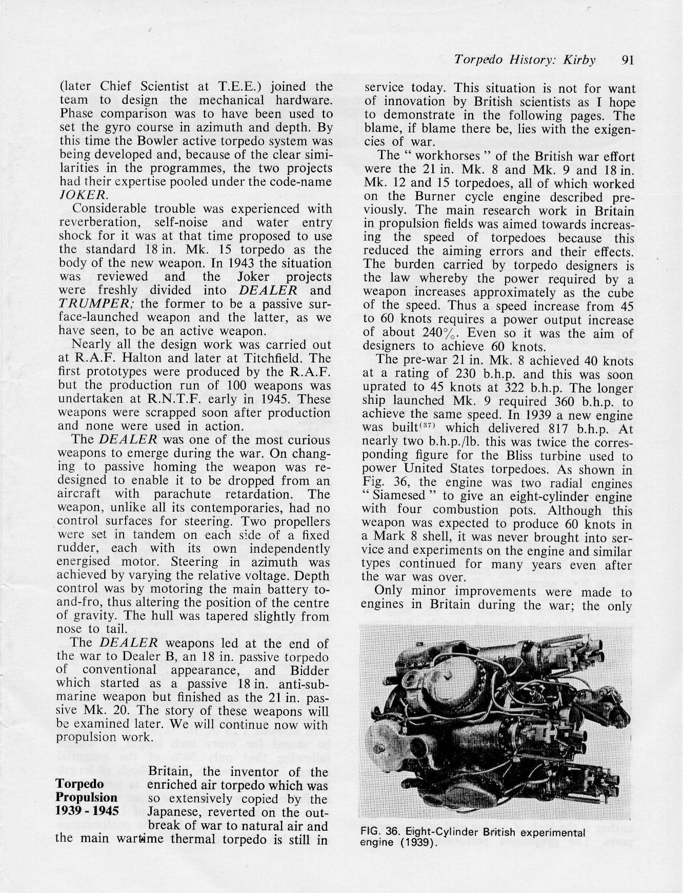

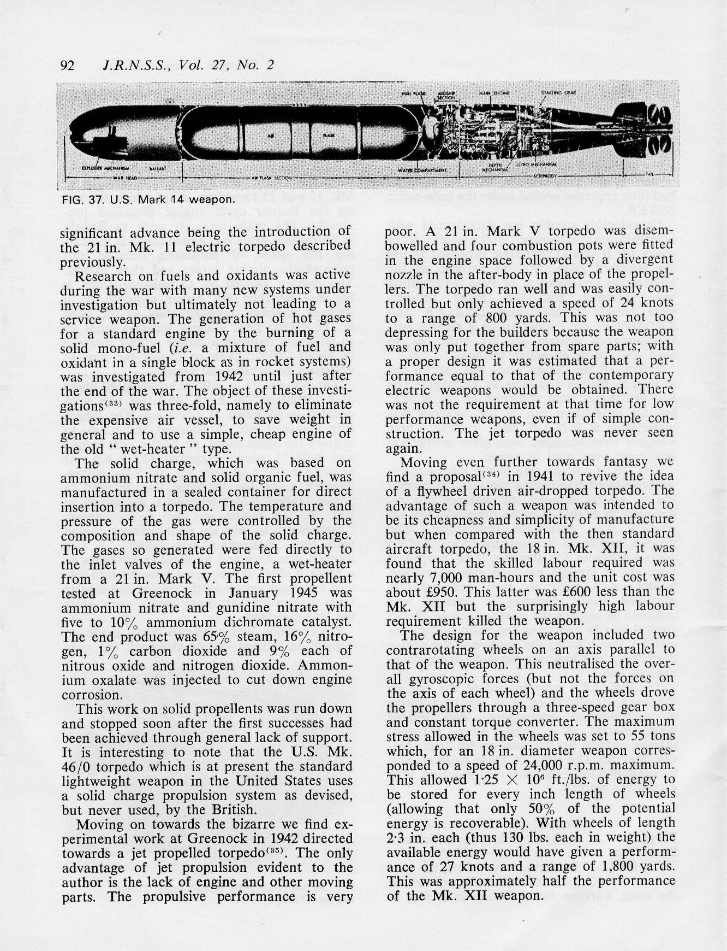

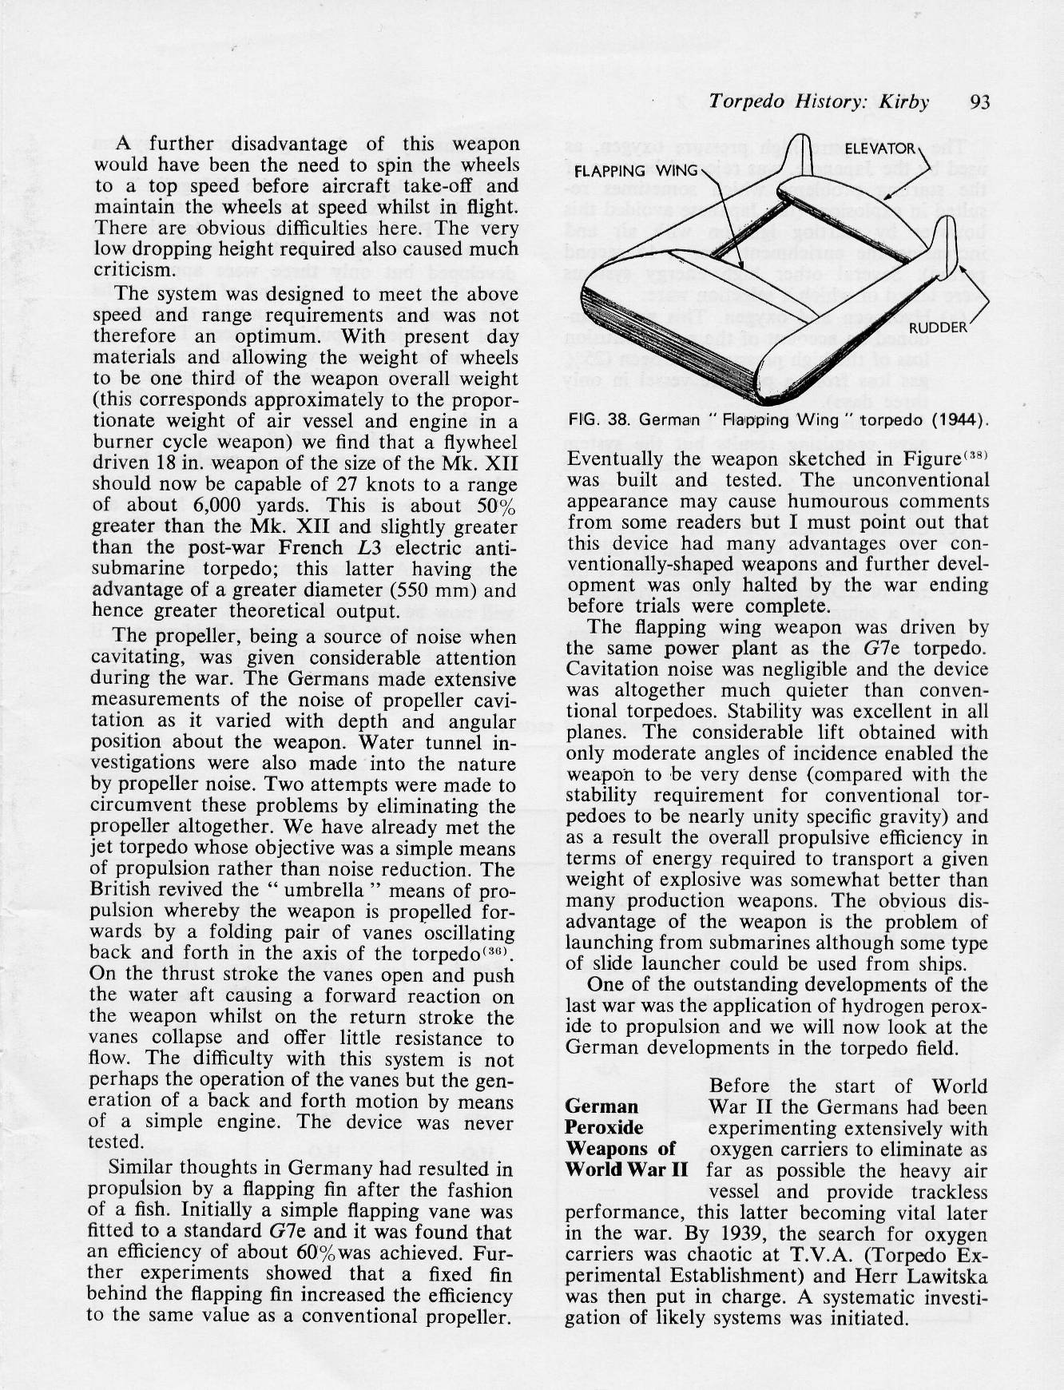
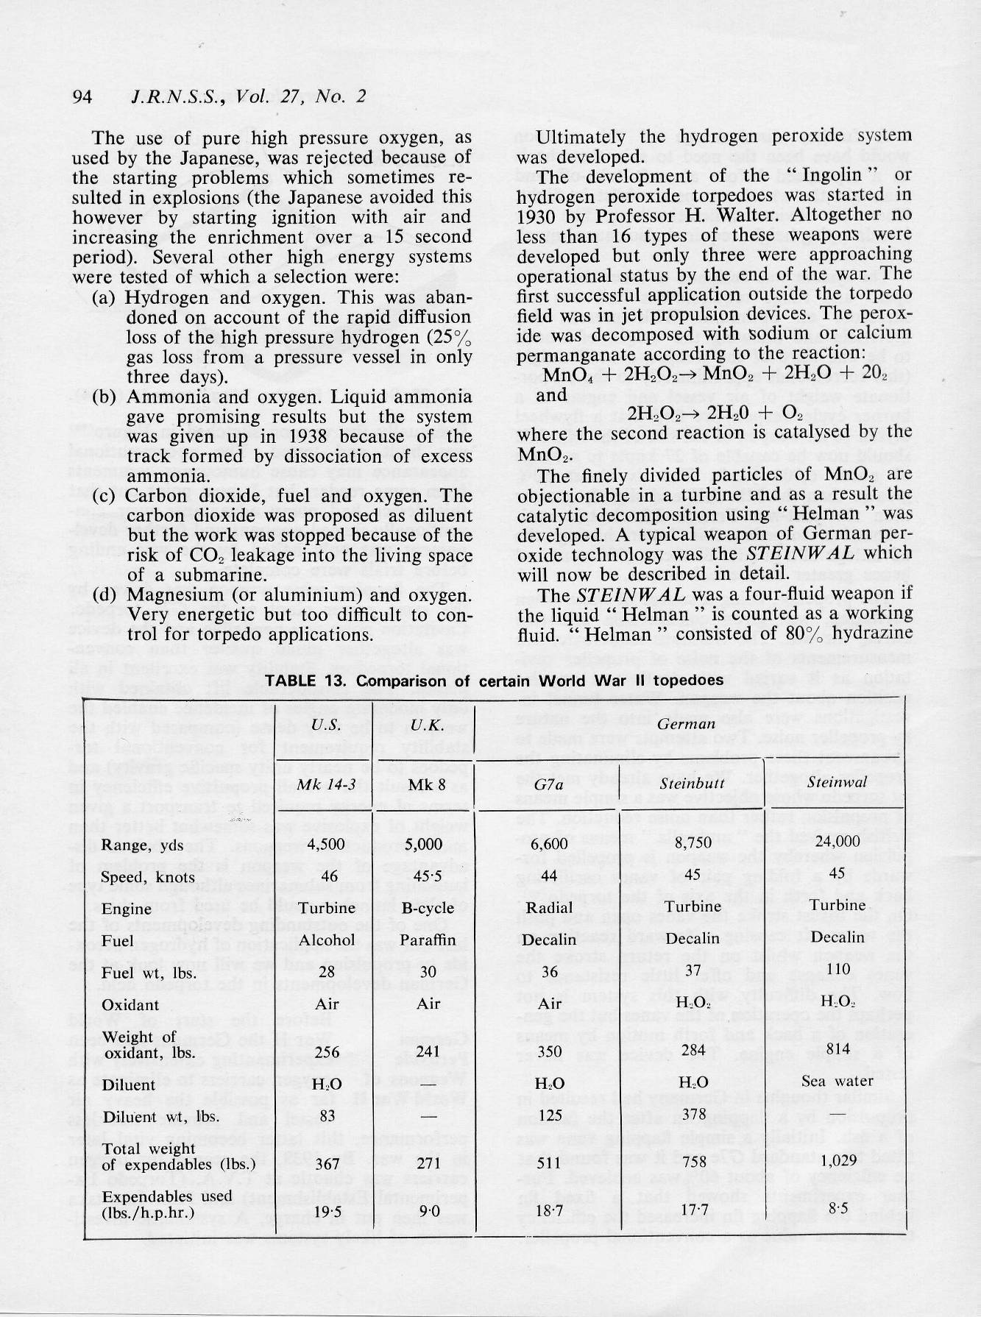

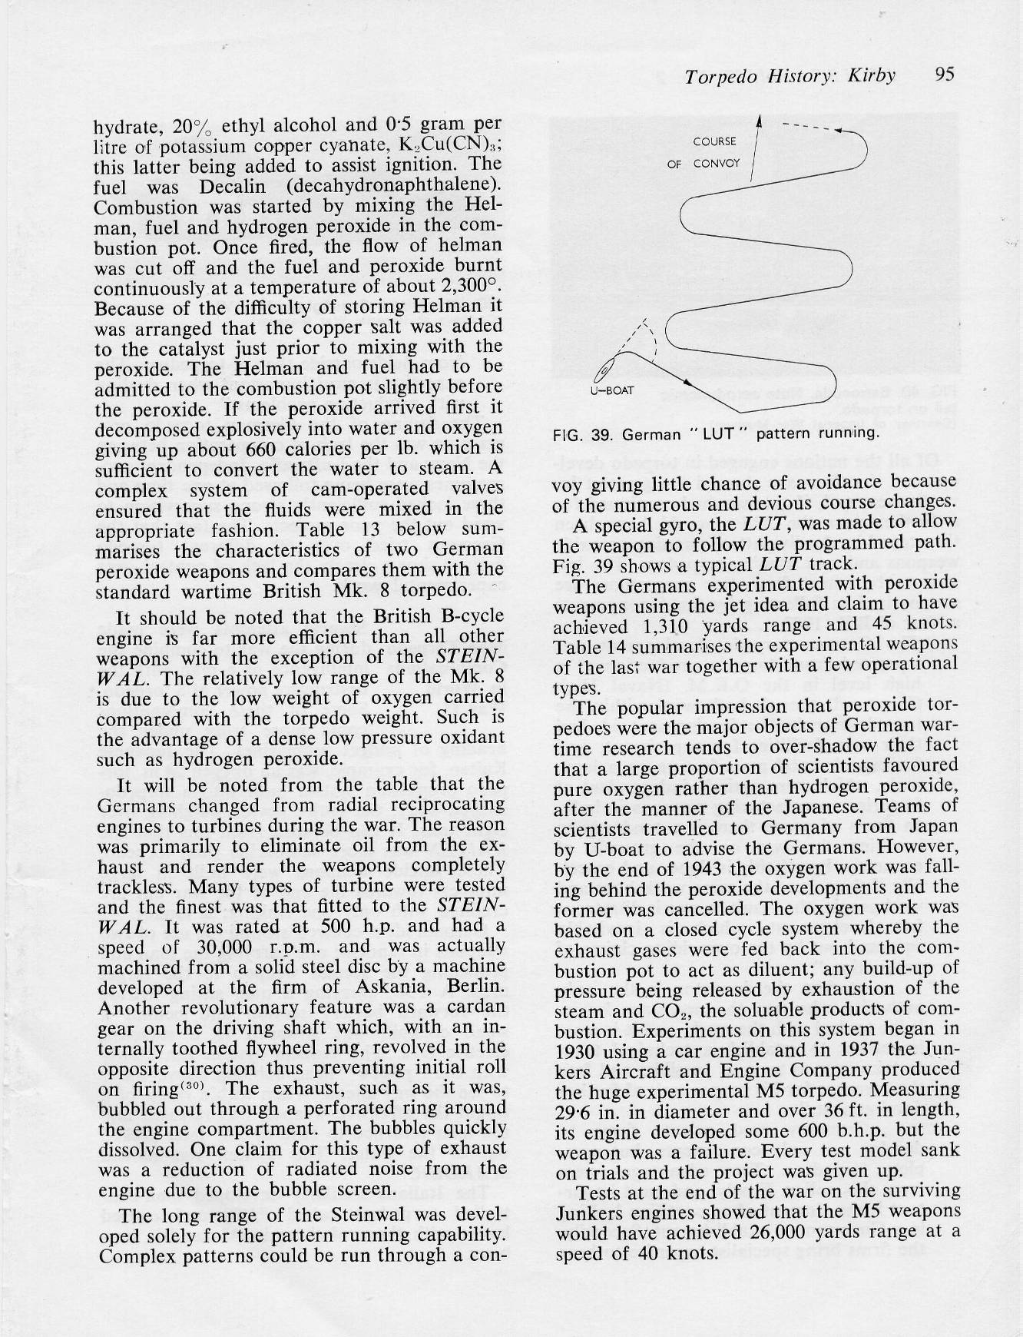

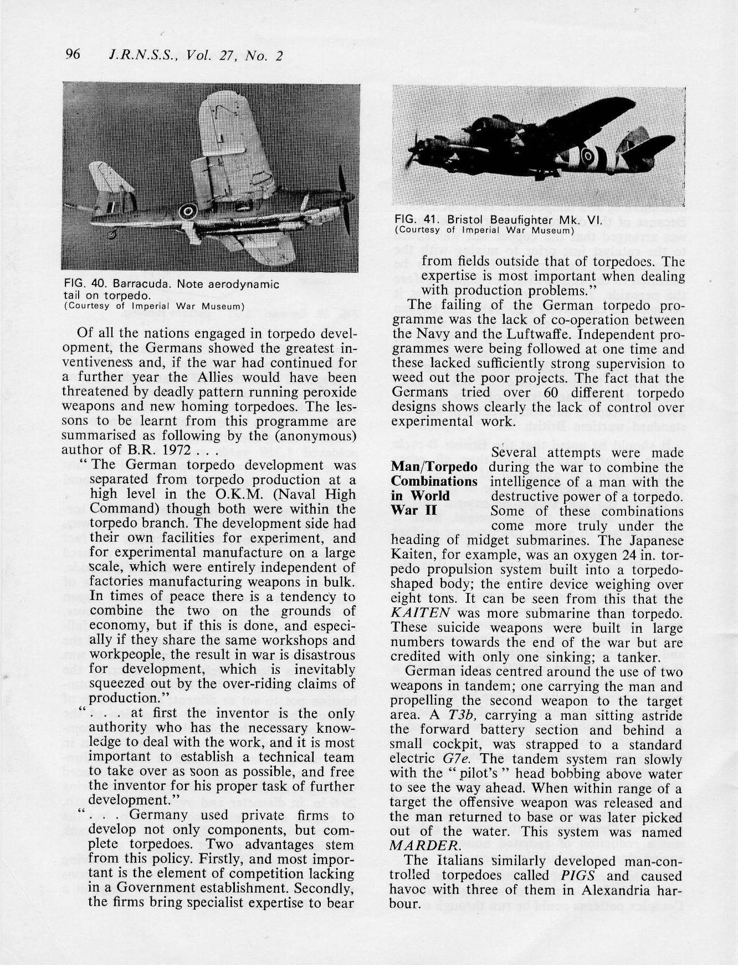

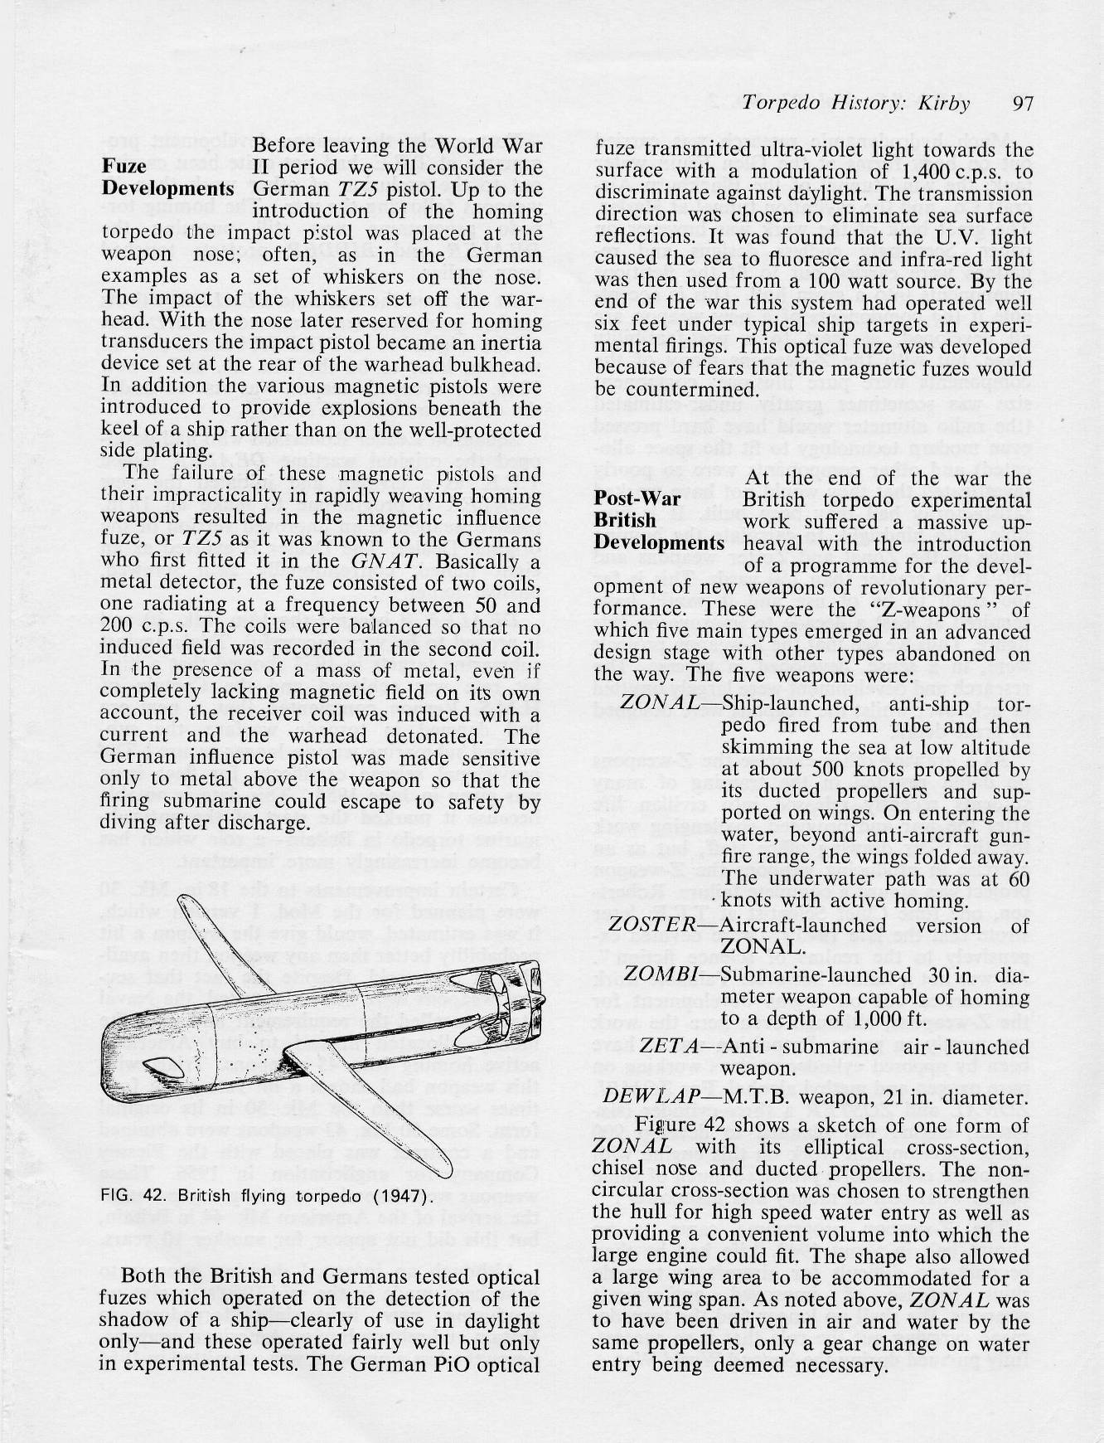

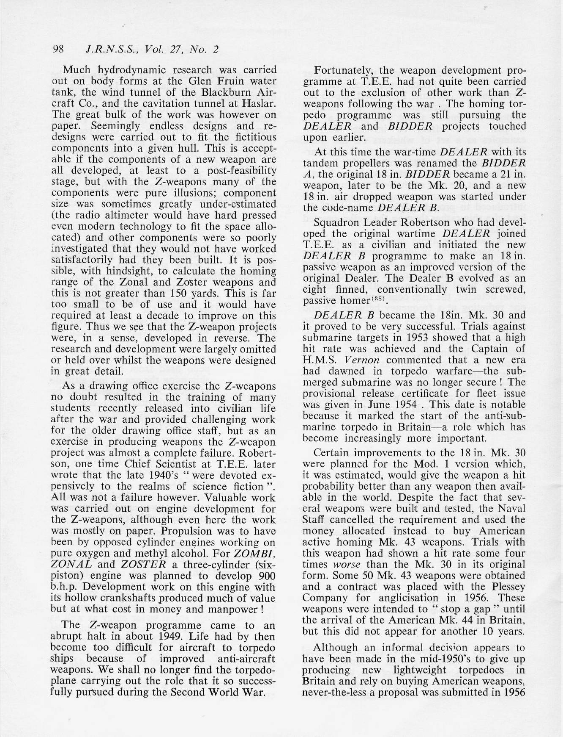

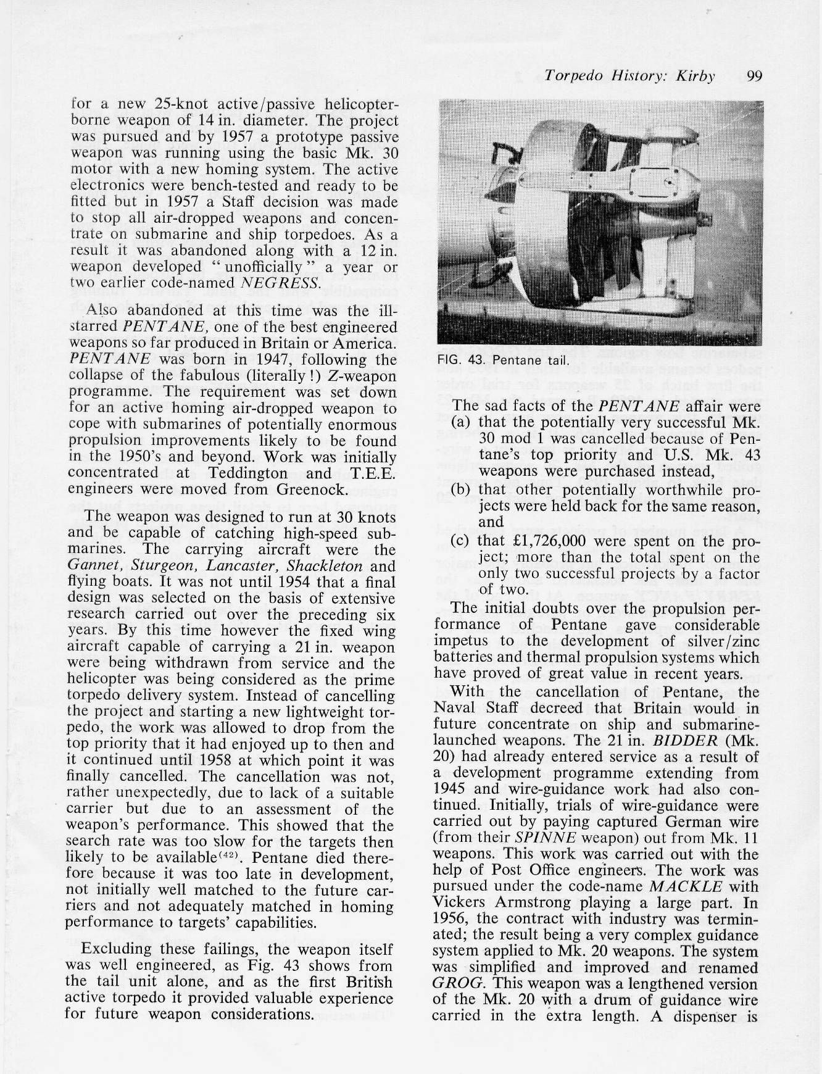

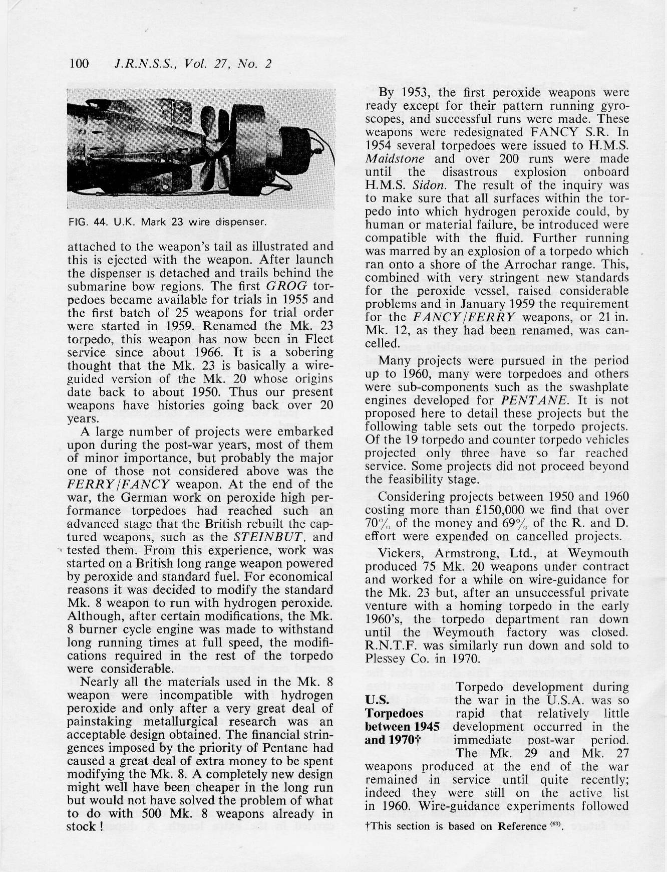

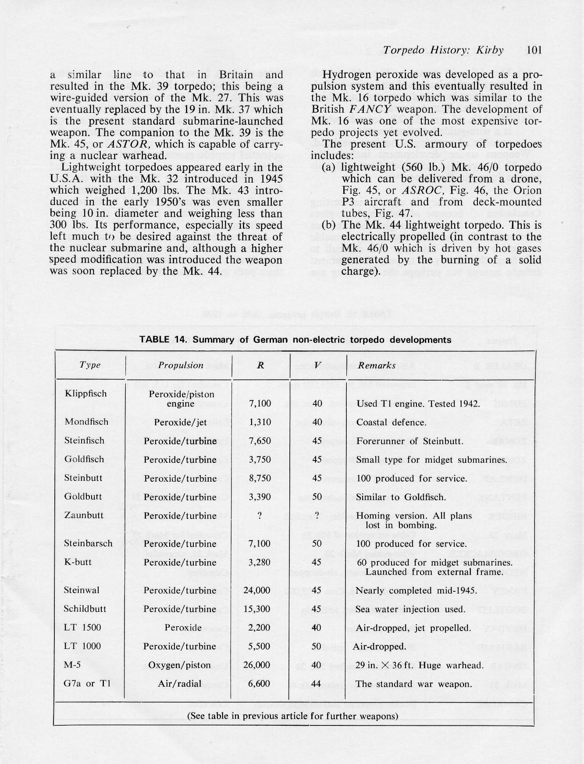
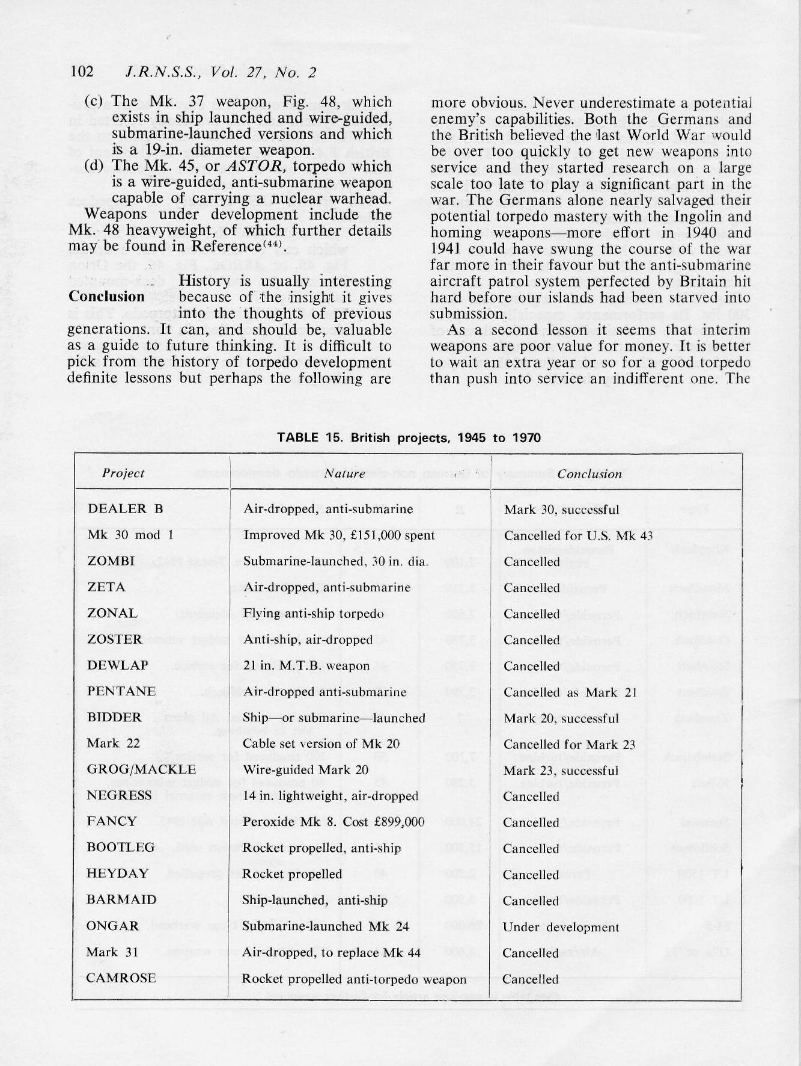
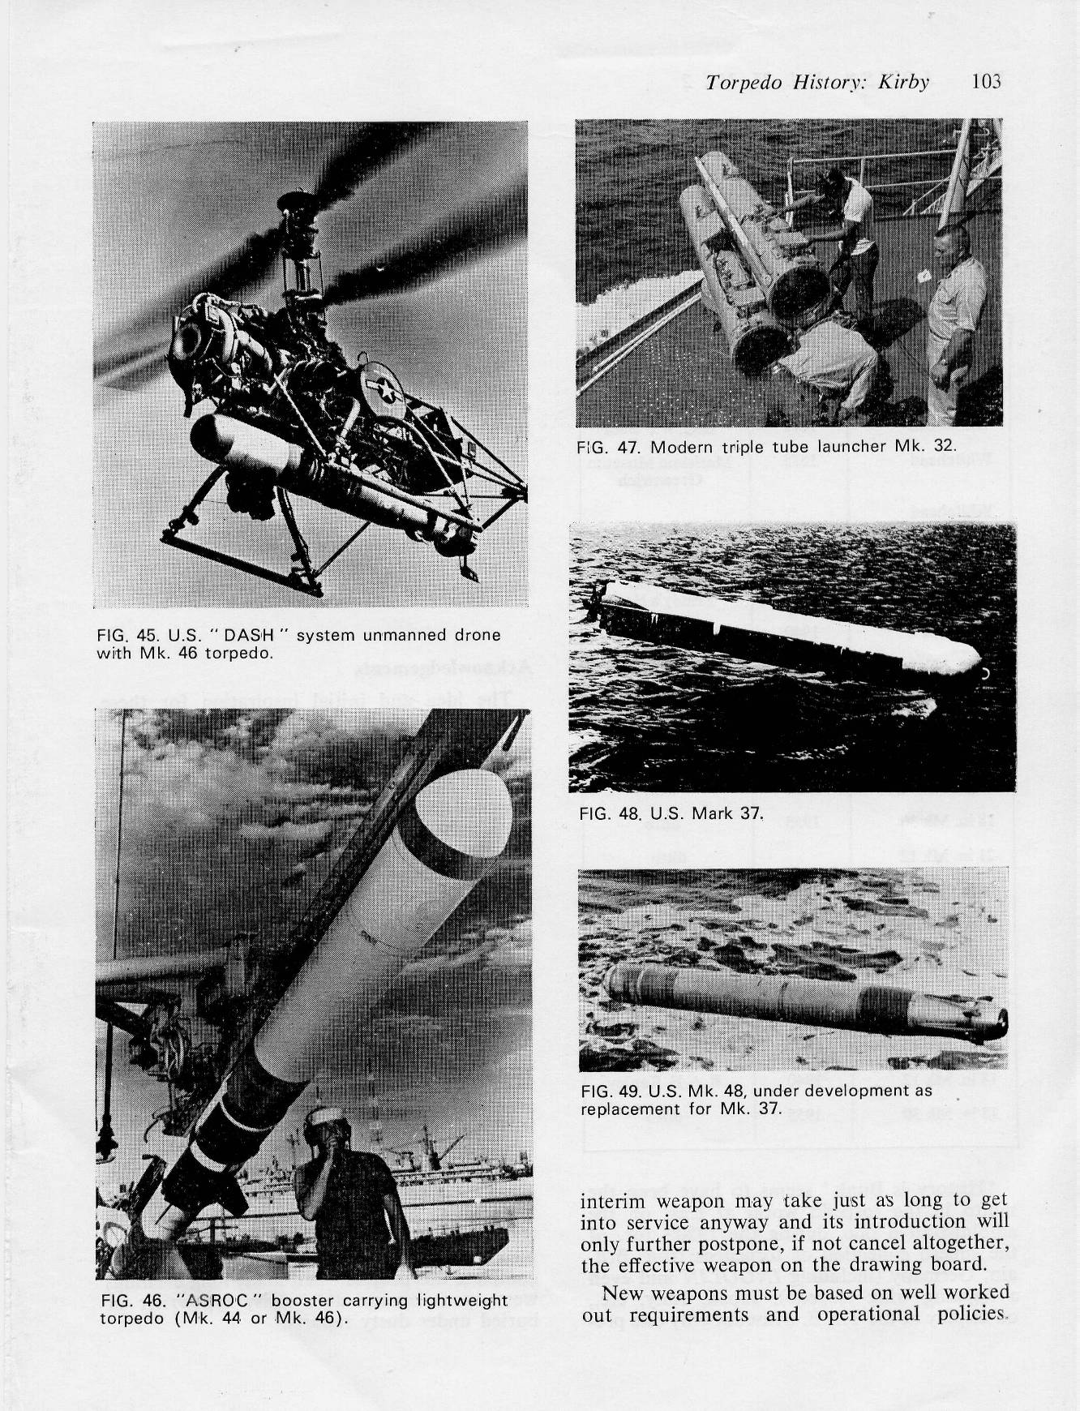

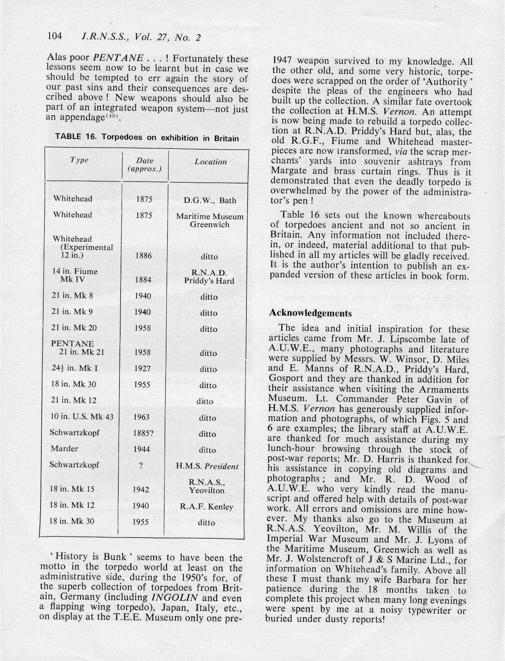

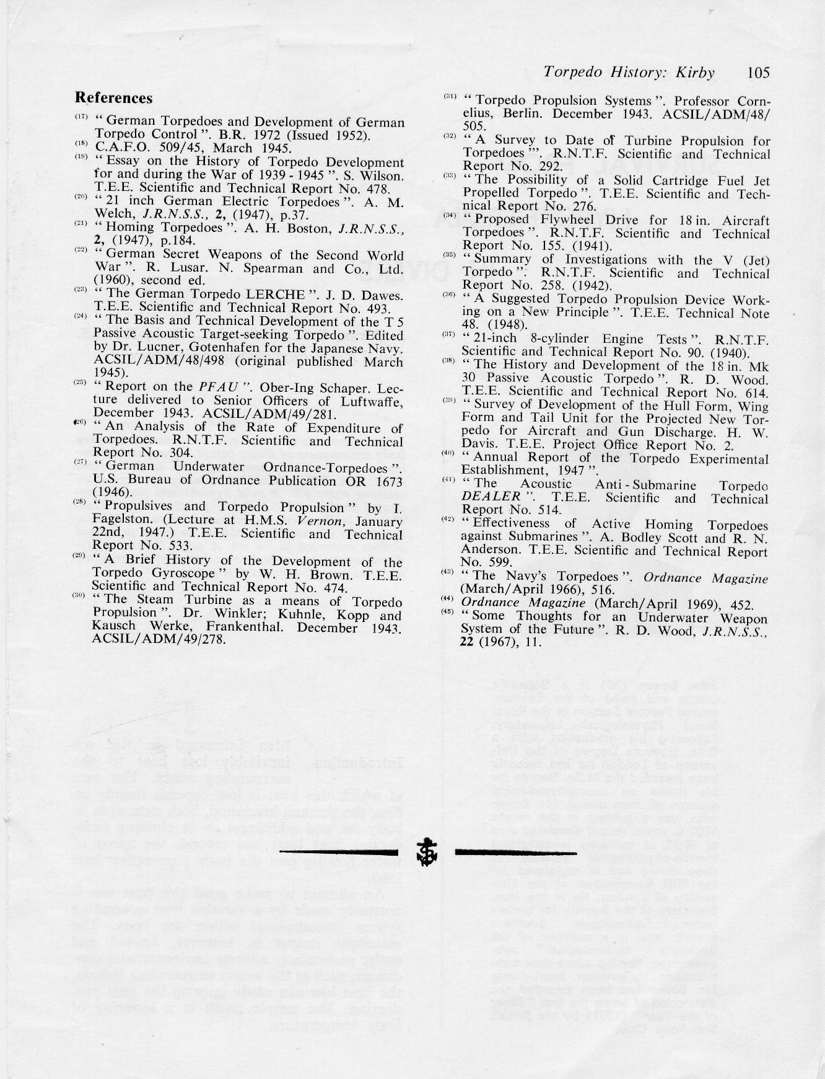

Gray, E., “The Devil’s Device”. Naval Institute Press, Annapolis (1991).
Gray, E., “19th Century Torpedoes and Their Inventors”. Naval Institute Press, Annapolis (2004).
A model of this weapon can be seen at the EXPLOSION! Museum, Gosport, Hampshire - see http://www.explosion.org.uk/ and do a ‘simple search’ for item catalogued PH1993.640
www.geoffkirby.co.uk/Rocket-Torpedoes.pdf

